Quantum Tunneling & Wave Packets

By: Dayton Flores

University of Nevada-Las Vegas



# Table of Contents

## Abstract …………………………………………………… 2

## Key Concepts …………………………………………………… 3

## Quantum Tunneling (Software Manual). …………………………………………………… 6

Getting Started ............................................................. 7

Constant Potential ............................................................. 11

*E > V* …………...………………….. 11

*E < V* …………...………………….. 12

Step Potential ............................................................. 13

*E > V1, V2* …………...………………….. 13

*E > V1* …………...………………….. 14

*E < V1, V2* …………...………………….. 15

Single-Well Potential ............................................................. 16

*E > V1, V2, V3* …………...………………….. 16

*E > V1, V3* …………...………………….. 19

*E < V1, V2, V3* …………...………………….. 22

Double-Well Potential ............................................................. 23

*E > V1, V2, V3, V4, V5* …………...………………….. 23

*E > V1, V2, V3, V5* …………...………………….. 26

*E > V1, V2, V3* …………...………………….. 29

*E < V1, V2, V3*, *V4, V5* …………...………………….. 32

## Application …………………………………………………………………………………… 33

## References …………………………………………………………………………………… 34

# Abstract

Quantum tunneling is a phenomenon that occurs in quantum mechanics when a subatomic particle passes through a potential barrier that it could not overcome under classical mechanics conditions.

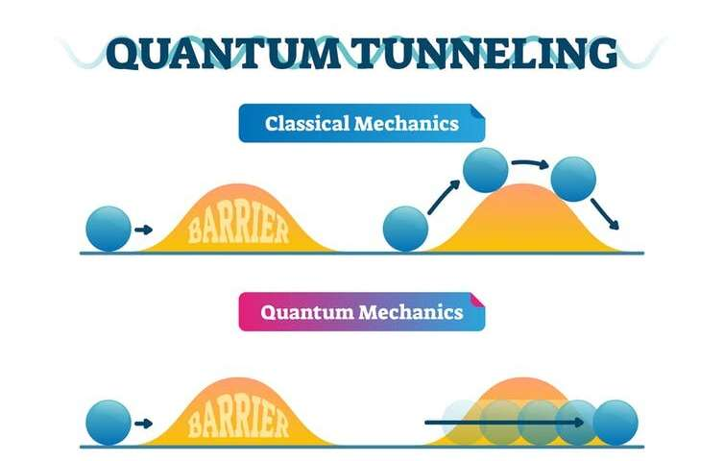

Fig. 1. Simple picture depicting an object overcoming a potential barrier in classical physics v. a particle overcoming a potential barrier in quantum physics (NanoLog).

This effect is crucial to many applications of different technologies, such as flash memory and quantum computing, while also being instrumental in physical phenomena such as nuclear fusion in stars (such as the Sun) and radioactive decay. The acceptance of quantum tunneling amongst scientists has led to the invention of scanning tunneling microscopes, which are used to understand nature on a nano scale. While being fairly tough to visualize without software, quantum tunneling remains a fundamental concept in quantum mechanics and should be well understood by everyone that works with semiconductors or computer microarchitecture.

**Key Concepts**

A macroscopic analogy can help put the notion of quantum tunneling into a familiar perspective; suppose a tennis ball is being thrown against a wall repeatedly with a constant kinetic energy KB. This KB is not enough to ever break the wall, but suppose after a few billion attempts, the ball suddenly appears on the other side of the wall with the same kinetic energy KB. This could only happen due to quantum tunneling, and is a direct consequence of wave-particle duality, which states that everything in the universe has particle properties as well as wave properties.

Fig. 2. An example that shows the photoelectric effect and Compton scattering, and the only solution is wave-particle duality (Purdue University).

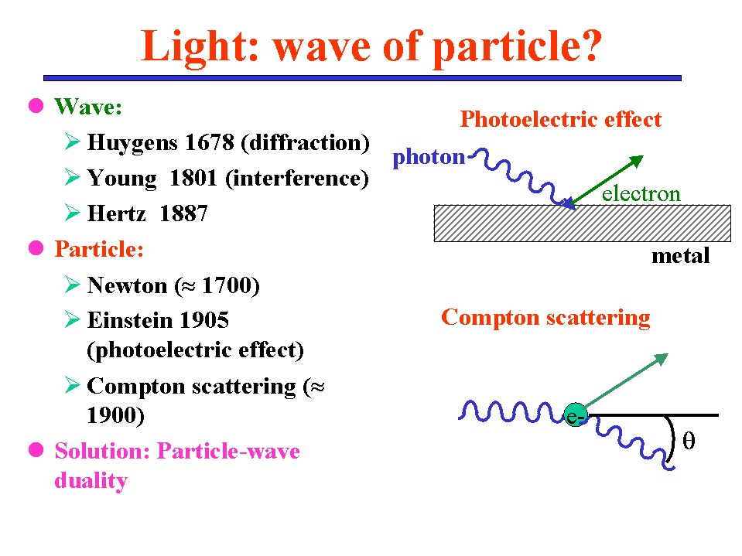

Relatively large objects (non-subatomic) are dominated by their particle properties and thus cannot have their wave properties observed, so it is theoretically impossible for the tennis ball to ever quantum tunnel through the wall. But as objects approach the subatomic level, their wave properties begin to take effect, and their behavior must then be described through solutions of the Schrödinger equation (i.e. wave functions ψ, whose norms describe the probability that a particle will be located at a certain position). If the tennis ball begins to shrink and approach a subatomic level, the possibility of quantum tunneling increases due to the tennis ball’s wave properties dictating a larger portion of its general nature.

The size of the ball (and in turn, its wave function and probability distribution) is not the only contributing factor to tunneling, as the energy the wall can withstand from the tennis ball before breaking (UW) and the width of the wall (WW) both contribute as well. If the wall is looked at as a quantum well, then its height would be UW and its width would be WW. The nature of the (now subatomic) tennis ball’s wave function ψB “leaks” into the quantum well and out of the other side of the well. In turn, ψB can be separated into three regions: ψB1 (before the wall), ψB2 (inside of the wall), and ψB3 (after the wall).

Fig. 3. Shows the properties of the tennis ball’s wave function when thrown against the wall in the quantum world (Sapozhnikov).

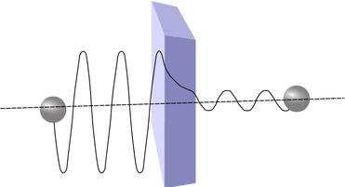

Both ψB1 and ψB3 are sinusoidal, with the amplitude of ψB1 being much larger than the amplitude of ψB3 (which means the probability of the ball being found “before the quantum well” is >> than the probability of the ball being found “after the quantum well”). This is a result of ψB2 being an exponentially decaying function, and if the quantum well is any bigger than ≈ 3nm, then ψB2 decays to ≈ 0 and quantum tunneling becomes theoretically impossible. However, if UW approaches KB and WW approaches 0, along with the tennis ball shrinking to a subatomic level, the probability of quantum tunneling will begin to increase, with the ball maintaining KB after tunneling.

As unsettling as the idea of quantum tunneling is, it has even more perplexing properties. The time this process takes has been measured multiple times at the Australian Attosecond Science Facility to take no longer than 1.8 attoseconds (10-18 s, or a less than a billionth or a nanosecond). Considering that it takes an electron a couple hundred attoseconds to completely revolve around the nucleus of an atom, this is a remarkable measurement. Many quantum physicists have theorized quantum tunneling to happen faster than the speed of light, and the new experiment only helps set an upper limit on the time it takes a particle to quantum tunnel. The tunneling time sets a limit on how quickly transistors can switch, so the measurement of this time makes the idea of super-fast technology and computers more realistic in the foreseeable future.

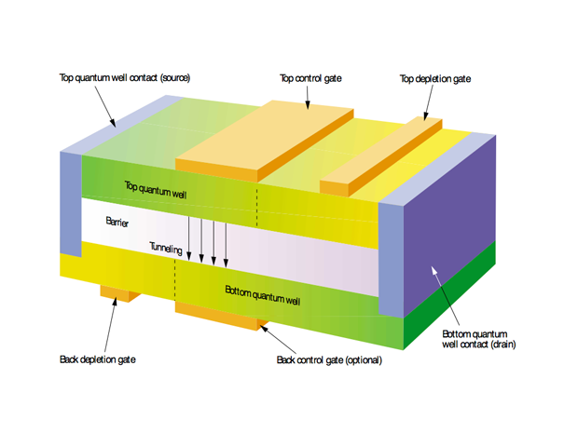

Fig. 4. Shows the basics of a MOSFET, and how quantum tunneling is used to switch the state of the transistor. Since MOSFETs (specifically CMOS) are present in almost every electronic device, the switching speed sets an upper limit on almost all electronics (Geppert).

**Quantum Tunneling (Software Manual)**

The free Quantum Tunneling & Wave Packets software provided by PhET (University of Colorado Boulder) allows the user to simulate quantum tunneling at modifiable energy levels within four different potential configurations (constant, step, single well, double well). The user can then observe the values of the wave function separately (real, imaginary, phase) on a femtosecond timescale, as well as the probability density. Understanding and visualizing quantum tunneling will help to understand the basis of two of the most important pieces credited to the advancement of modern technology: semiconductors and transistors.

**Modifiable parameters include:**

* Potential energy structure
* Average total energy (eV)
* Potential energy values (eV)
* Direction of incoming wave
* Initial width of wave packet (nm)
* Initial position of wave packet (nm)
* Electron wave function form
* Time (fs)

**Observational values include:**

* Interactive graph of potential energy structure
* Potential & total energy values
* Graph of wave function (real, imaginary, magnitude, phase)
* Graph of probability density
* Reflection & transmission probabilities

## Getting Started

**System Requirements**

* Windows XP/7/8.1/10 **OR** OS x 10.9.5 (or later) **OR** any version of Linux
* 1.7 MB
* Java Runtime Environment 8 (or later)
  + Included in Java Development Kit™)

**Installing & Configuration (Windows/Mac/Linux)**

1. Navigate to the following URL:

<https://phet.colorado.edu/en/simulation/quantum-tunneling>

1. Click 
2. Open the downloaded file:

***quantum-tunneling\_en.jar***

1. After loading screen, the application should open:

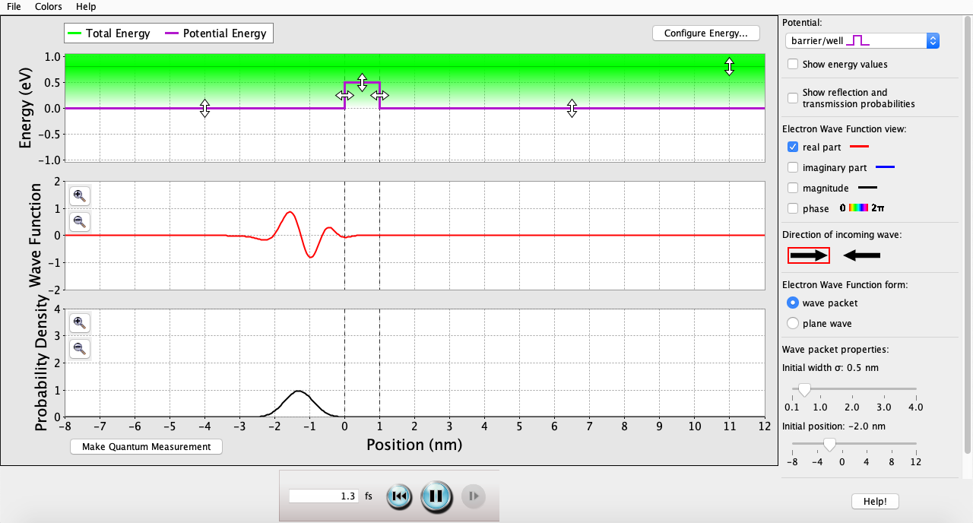

## Getting Started (continued)

1. The Configurations on the right are as follows:

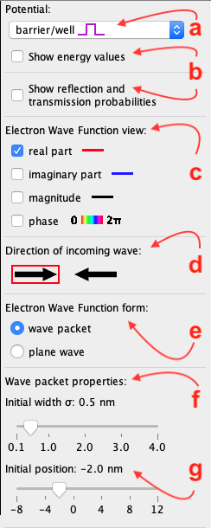

1. Drop-down menu to select Potential:

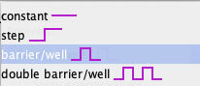

1. Check boxes to show Energy Values *(recommended)* or Reflection & Transmission Probabilities *(recommended)*
2. Choose which parts of the Wave Function to view (in Wave Function Graph)
3. Select the direction the electron will be traveling
4. Select between Wave Packet (individual particle) and Plane Wave (continuous stream of particles)
5. Select the initial width of the Wave Packet (nm)
6. Select the initial position of the Wave Packet relative to the graph (nm)

## Getting Started (continued)

1. Configure the energy values by clicking Crucial SSD:private:var:folders:f5:4yswzfsn4_x4n1dljqm6qfxr0000gn:T:TemporaryItems:Screen Shot 2019-04-15 at 10.43.30 PM.png near the top right corner.
2. The following menu should pop up:
3. Energy visualization of the selected settings from (b), (c), (d), (e)
4. Drop-down menu to select Potential:



1. Average Total Energy (eV)
2. Potential Energy of each section (eV)
3. Potential position & width (nm)

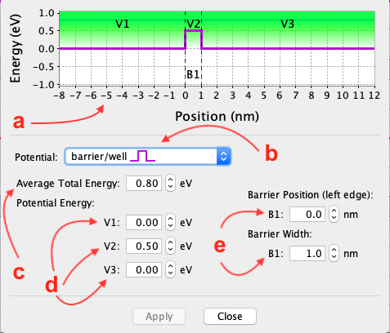

## Getting Started (continued)

1. Once these settings have been Applied, the user is taken to the main page of the application (from Step 4). This is where the user can visualize every configuration that has been made on a femtosecond timescale:

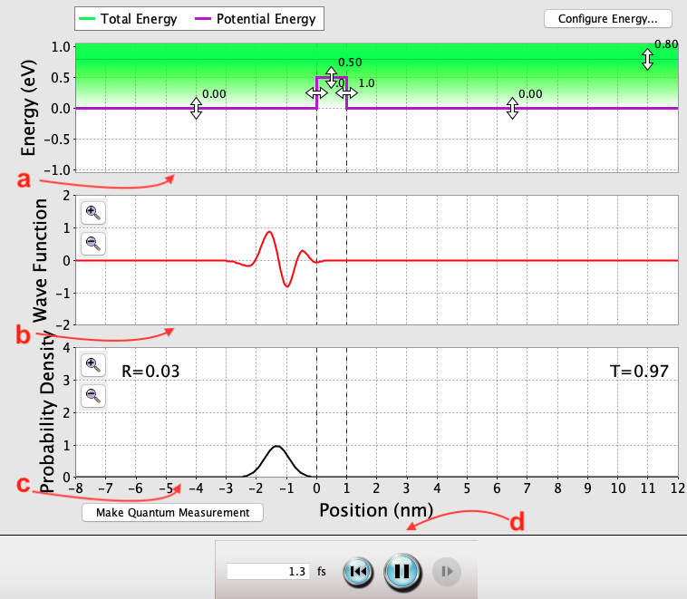

* 1. Energy visualization of the settings entered by the user
  2. Wave Function visualization of the electron (ψ) interacting with the Potential from (a) on a femtosecond timescale
  3. Probability Density visualization of the electron (|ψ2|) interacting with the Potential from (a) on a femtosecond timescale
  4. The Crucial SSD:Users:daytonflores:Desktop:Screen Shot 2019-04-16 at 12.10.11 AM.png restarts the time, and the Crucial SSD:Users:daytonflores:Desktop:Screen Shot 2019-04-16 at 12.10.22 AM.png pauses the graphs for observation.

## Constant Potential

**Average Energy (E) > Potential (V)**

**0 fs**: T = 1.00. As long as E is greater than a constant V, the electron will always transmit. This is because there are no potential barriers for the electron to reflect from.

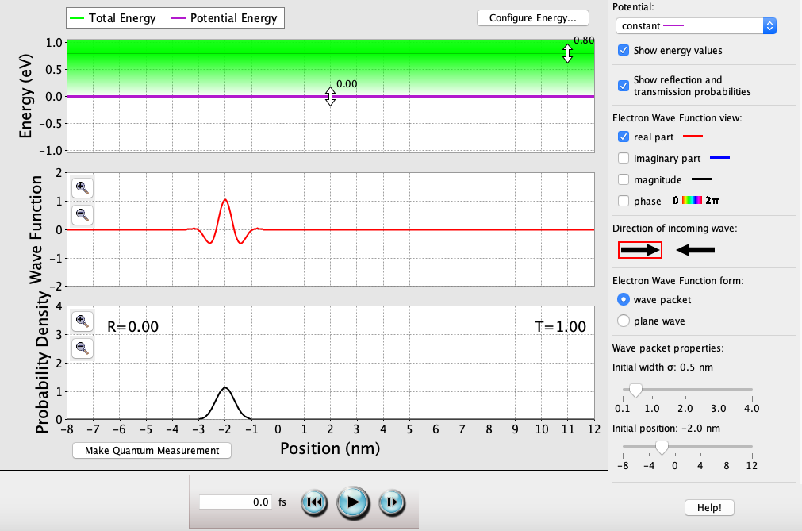

**10 fs**: T = 1.00. Regardless of the time passed, E is always greater than V and there are still no potential barriers for the electron to reflect from.

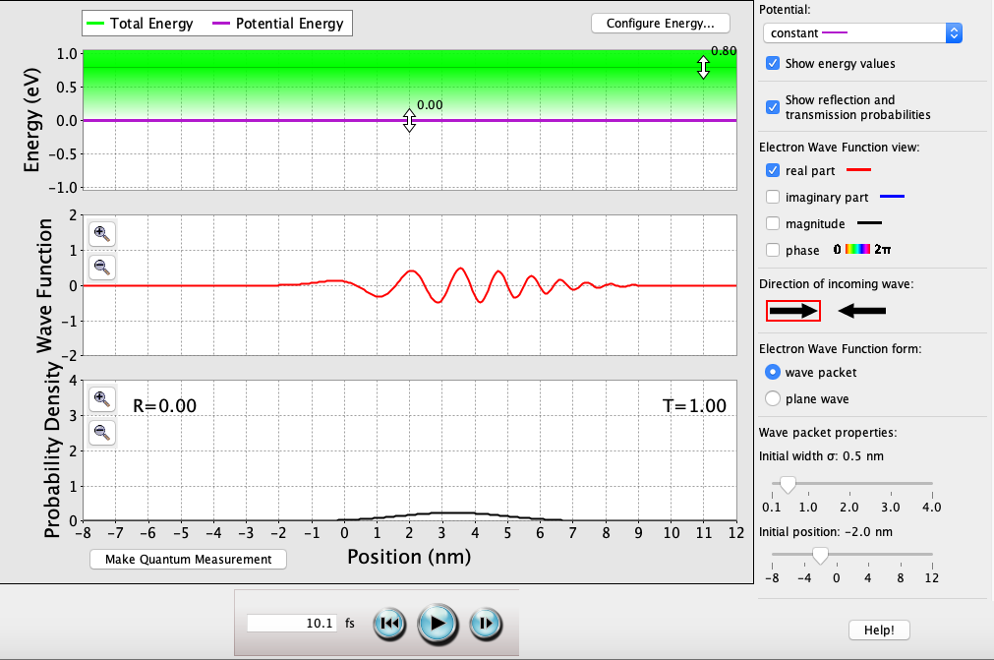

## Constant Potential (continued)

**Average Energy (E) < Potential (V)**

**0 fs**: T = ?. As long as E is less than a constant V, the electron will never exist within these bounds. This is because the barrier width approaches ∞ nm.

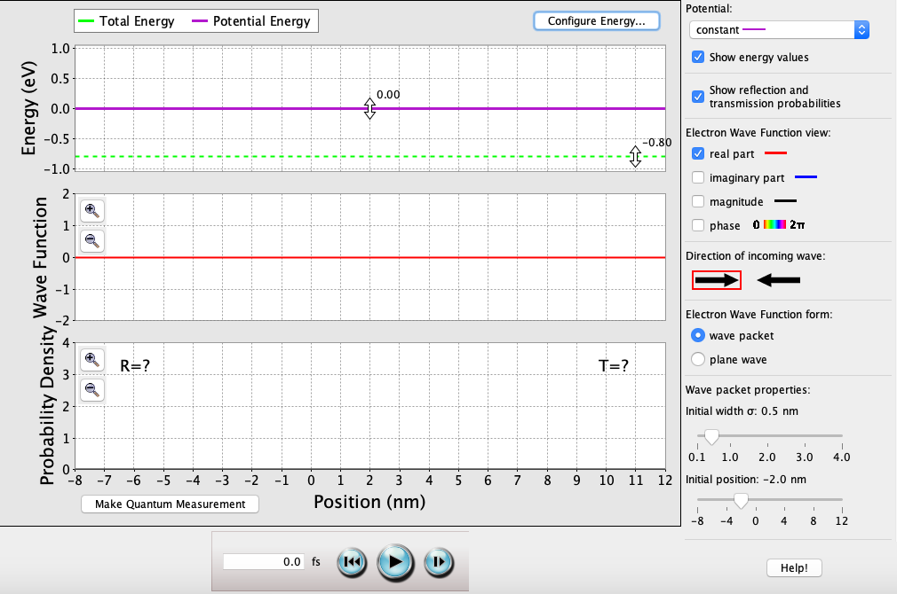

**10 fs**: T = ?. Regardless of the time passed, E is always less than V and the electron will never exist within these bounds. This is because the barrier width approaches ∞ nm.

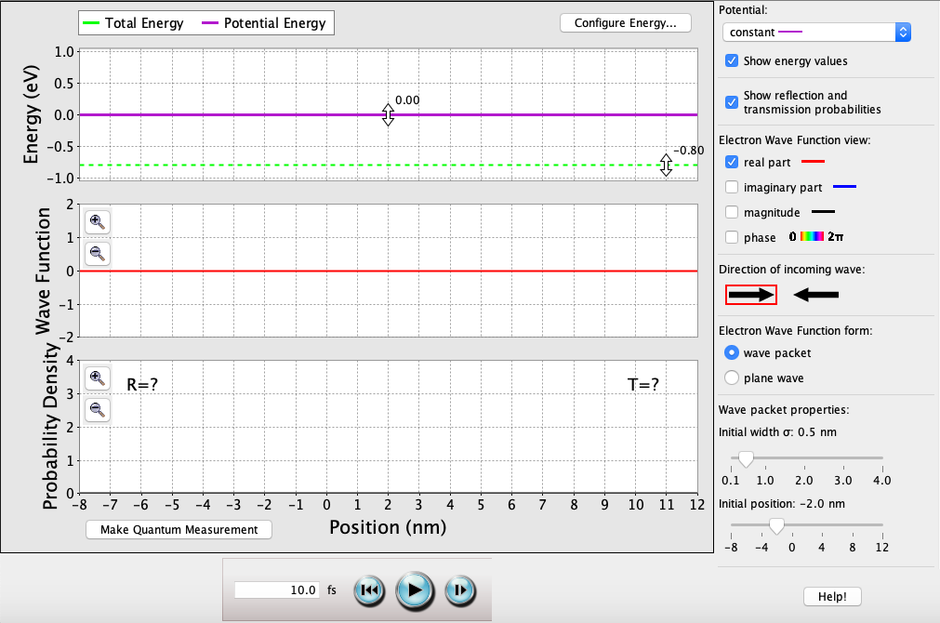

## Step Potential

**Average Energy (E) > Potentials (V1, V2)**

**0 fs**: T = 0.94. As long as E is greater than both V1 & V2, the electron will most likely transmit through the stepped potential.

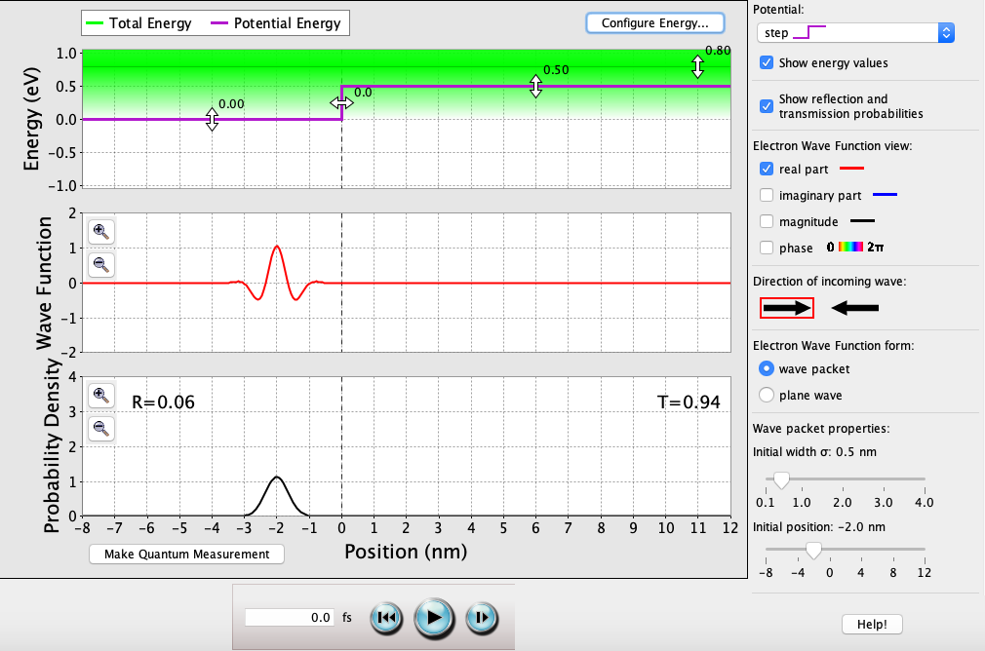

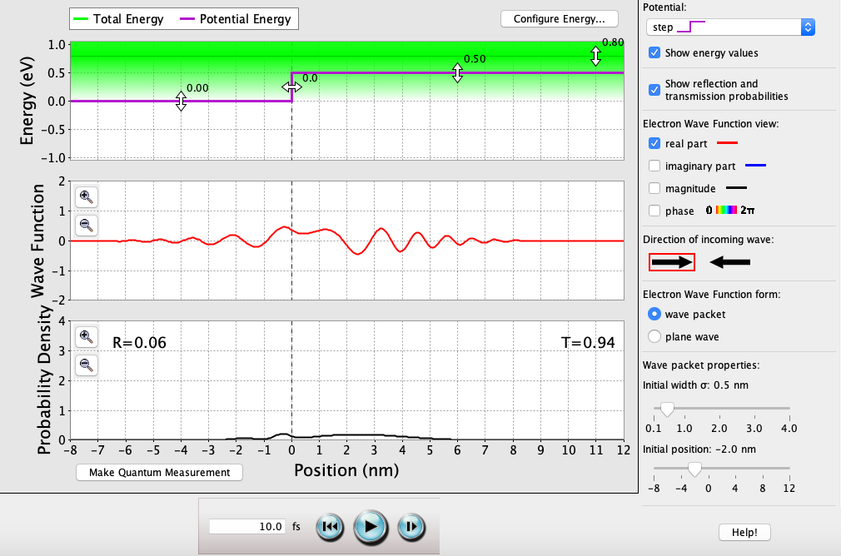

**10 fs**: T = 0.94. Majority of the wave function will be transmitted through the stepped potential, but since there is a rise in potential, a portion of the wave function is reflected.

## Step Potential (continued)

**Average Energy (E) > Potential (V1)**

**0 fs**: T = 0. As long as E is greater than V1 and less than V2, the electron will always reflect off the step. This is because the barrier width of the stepped potential approaches ∞ nm.

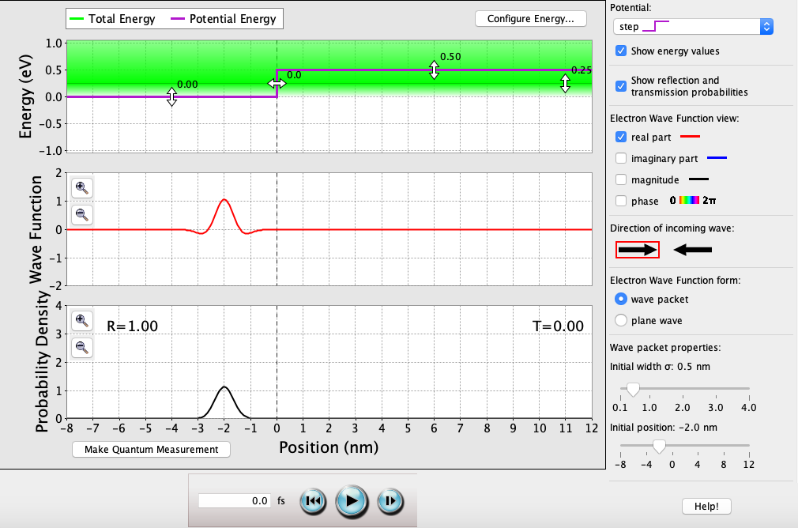

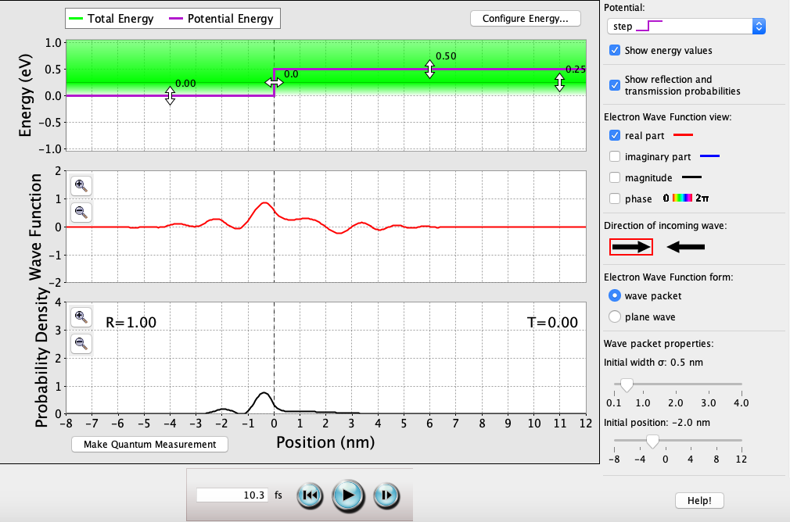

**10 fs**: T = 0. Regardless of the time passed, the electron will always reflect off the step. This is because the barrier width of the stepped potential approaches ∞ nm.

## Step Potential (continued)

**Average Energy (E) < Potentials (V1, V2)**

**0 fs**: T = ?. As long as E is less than both V1 & V2, the electron will never exist within these bounds. This is because the barrier width approaches ∞ nm.

**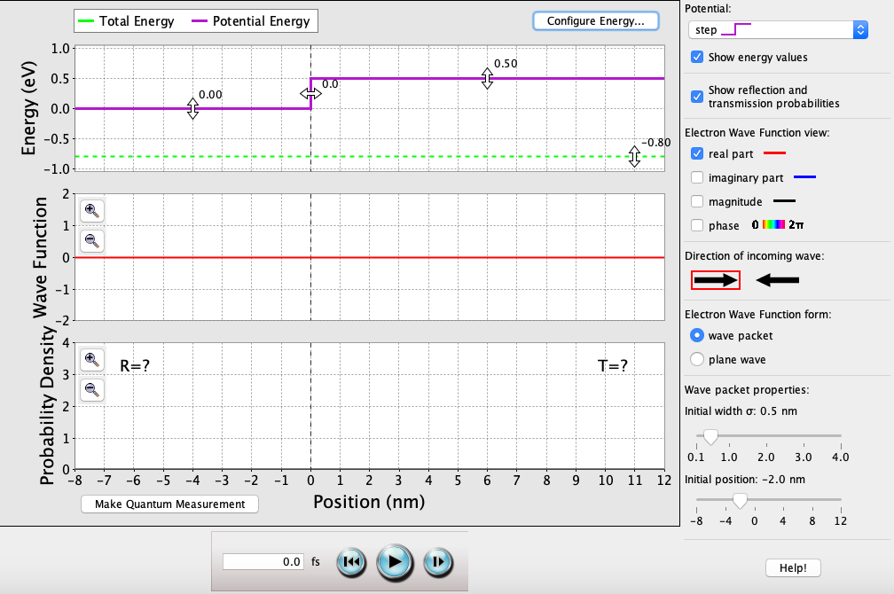**

**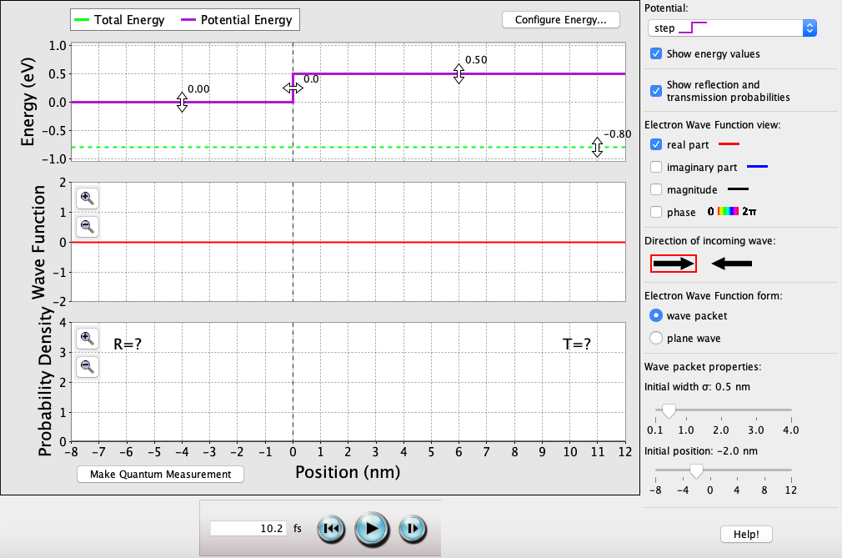**

**10 fs**: T = ?. Regardless of the time passed, E is always less than V1 & V2 and the electron will never exist within these bounds. This is because the barrier width approaches ∞ nm.

## Single-Well Potential

**Average Energy (E) > Potentials (V1, V2, V3)**

**0 fs**: T = 0.97. As long as E is greater than all of V1, V2, & V3, the electron will most likely transmit through the single-well potential.

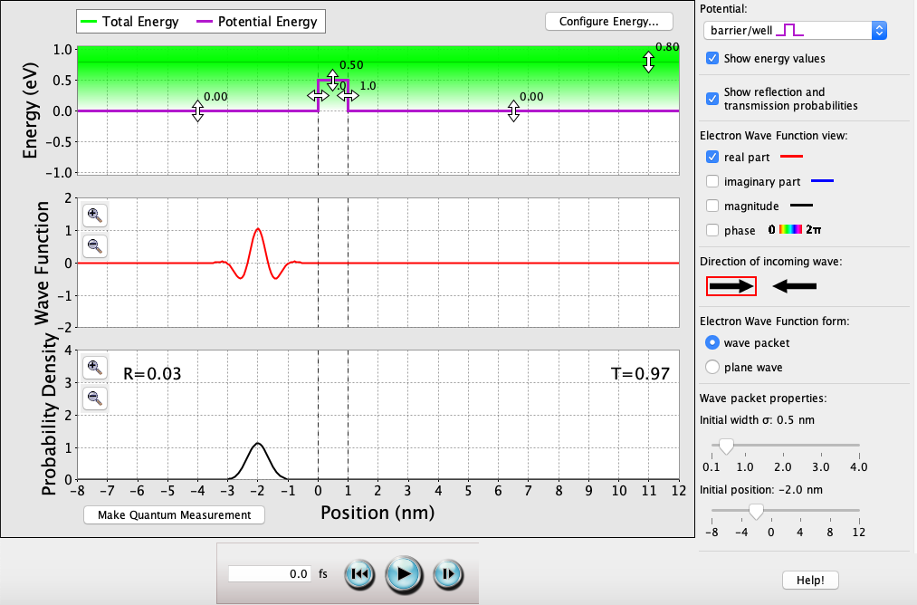

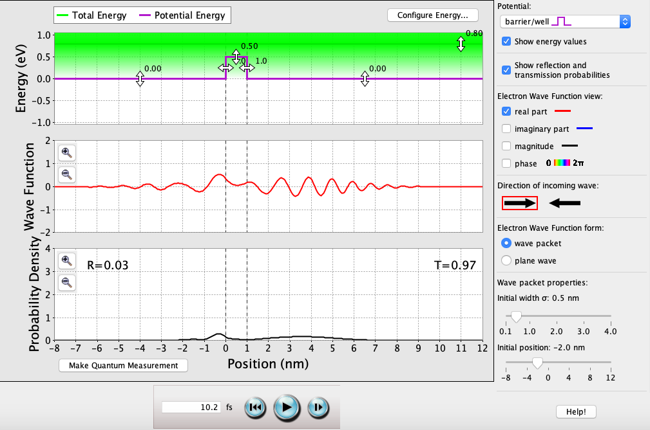

**10 fs**: T = 0.97. Majority of the wave function will be transmitted through into V2, and even less of that will be transmitted through into V3. As long as E is greater than both V1, V2 & V3, the electron will most likely transmit.

## Single-Well Potential (continued)

*Varying well-width:*

**VW = 1.1 nm**: T = 1.00.

Where *k0.5* = √(2*me*[*E* – *V2*] / *ħ*2) ≈ 2.81 \* 109 (kg · J-1 · s-2)1/2.

As long as E > V2, the perfect transmission probability oscillates with each solution of *k0.5a* = *n*π 🡪 *n* = *k0.5a*/π, and in this case *a* = 1.1 nm.

So (2.81 \* 109 (kg · J-1 · s-2)1/2) \* 1.1 nm / π = 0.98 ≈ (n = 1), so T = 1.00.

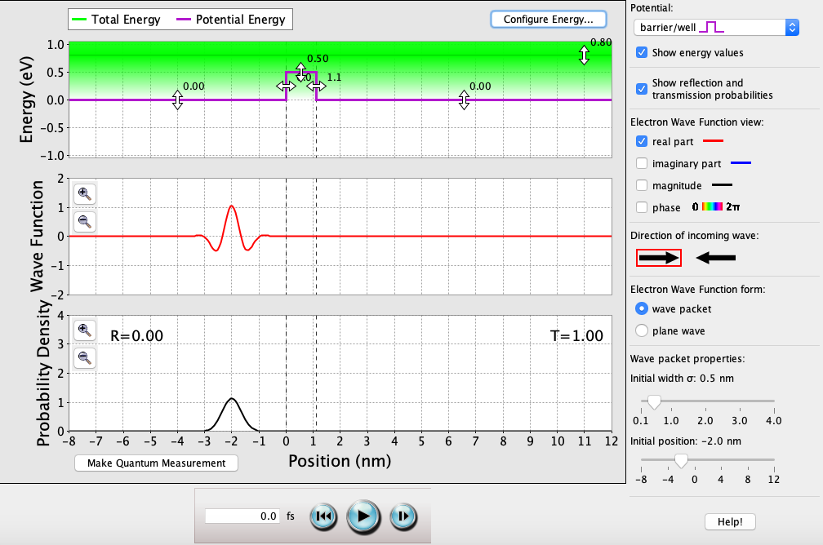

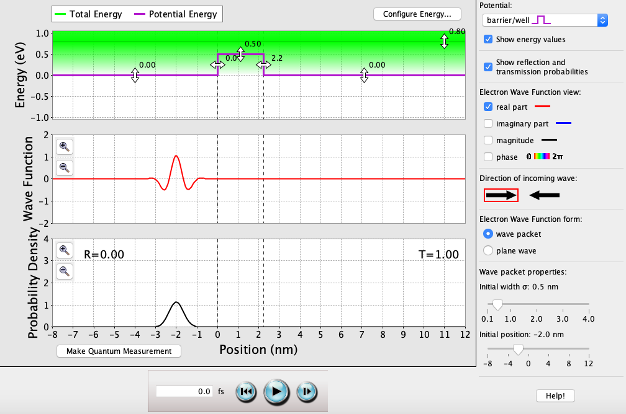

**VW = 2.2 nm**: T = 1.00.

Where *k0.5* = √(2*me*[*E* – *V2*] / *ħ*2) ≈ 2.81 \* 109 (kg · J-1 · s-2)1/2.

As long as E > V2, the perfect transmission probability oscillates with each solution of *k0.5a* = *n*π 🡪 *n* = *k0.5a*/π, and in this case *a* = 2.2 nm.

So (2.81 \* 109 (kg · J-1 · s-2)1/2) \* 2.2 nm / π = 1.96 ≈ (n = 2), so T = 1.00.

**VW = 3.4 nm**: T = 1.00.

Where *k0.5* = √(2*me*[*E* – *V2*] / *ħ*2) ≈ 2.81 \* 109 (kg · J-1 · s-2)1/2.

As long as E > V2, the perfect transmission probability oscillates with each solution of *k0.5a* = *n*π 🡪 *n* = *k0.5a*/π, and in this case *a* = 3.4 nm.

So (2.81 \* 109 (kg · J-1 · s-2)1/2) \* 3.4 nm / π = 3.03 ≈ (n = 3), so T = 1.00.

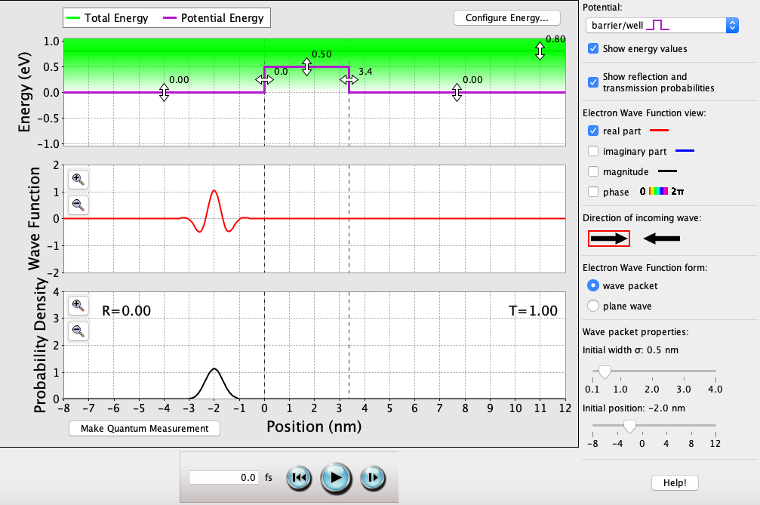

## Single-Well Potential (continued)

*Varying well-height:*

**V2 = -0.70 eV**: T = 1.00.

Where *k-0.70* = √(2*me*[*E* – *V2*] / *ħ*2) ≈ 6.27 \* 109 (kg · J-1 · s-2)1/2.

As long as E > V2, the perfect transmission probability oscillates with each solution of *k-0.70a* = *n*π 🡪 *n* = *k-0.70a*/π, and in this case *a* = 1.0 nm.

So (6.27 \* 109 (kg · J-1 · s-2)1/2) \* 1.0 nm / π = 1.99 ≈ (n = 2), so T = 1.00.

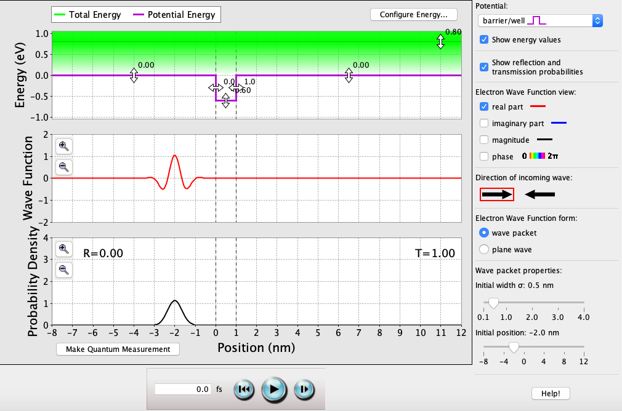

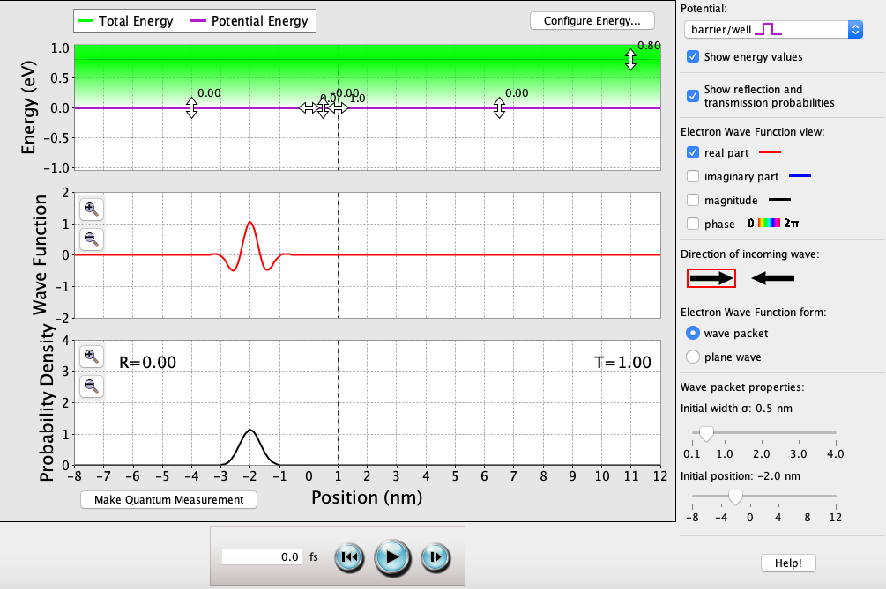

**V2 = 0 eV**: T = 1.00.

Where *k0* = √(2*me*[*E* – *V2*] / *ħ*2) = 0 (kg · J-1 · s-2)1/2.

As long as E > V2, the perfect transmission probability oscillates with each solution of *k0a* = *n*π 🡪 *n* = *k0a*/π, and in this case *a* = 0 nm.

So (0 (kg · J-1 · s-2)1/2) \* 0 nm / π = 0 = (n = 0), so T = 1.00.

**V2 = 0.42 eV**: T = 1.00.

Where *k0.42* = √(2*me*[*E* – *V2*] / *ħ*2) ≈ 3.16 \* 109 (kg · J-1 · s-2)1/2.

As long as E > V2, the perfect transmission probability oscillates with each solution of *k0.42a* = *n*π 🡪 *n* = *k0.42a*/π, and in this case *a* = 1.0 nm.

So (3.16 \* 109 (kg · J-1 · s-2)1/2) \* 1.0 nm / π = 1.01 ≈ (n = 1), so T = 1.00.

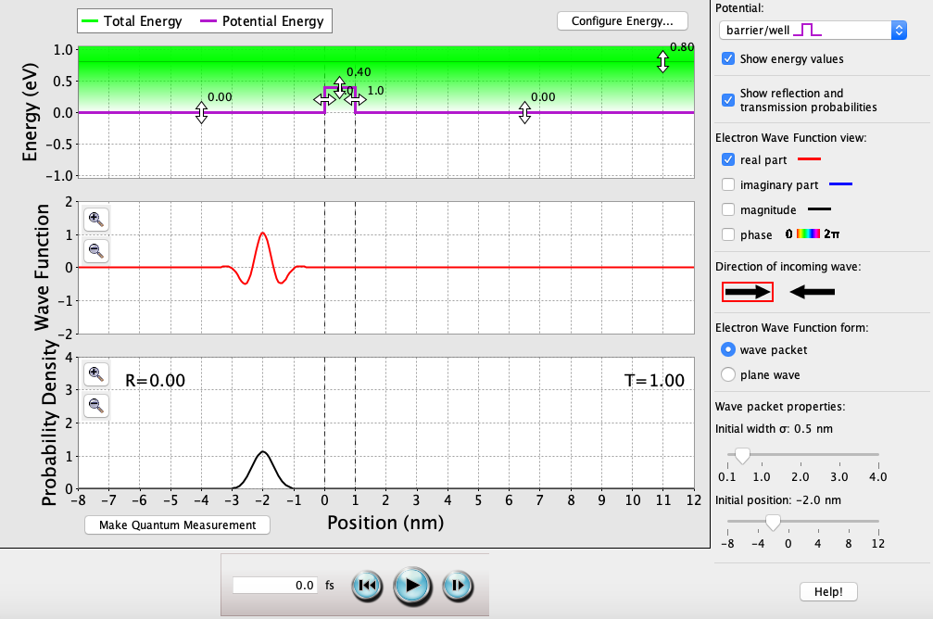

## Single-Well Potential (continued)

**Average Energy (E) > Potentials (V1, V3)**

**0 fs**: T = 0.02. As long as E is greater than both V1 & V3, the electron will most likely reflect off the single-well potential. The only way for the electron to overcome the barrier V2 is through quantum tunneling.

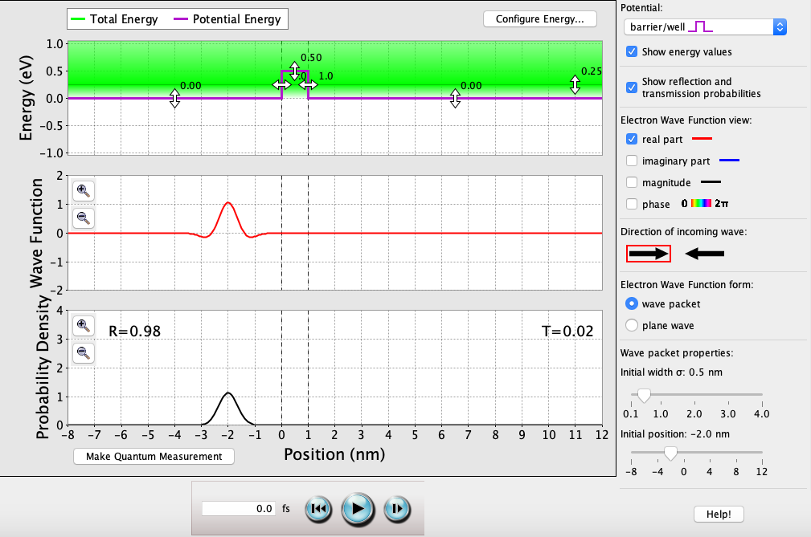

**10 fs**: T = 0.02. Majority of the wave function will be reflected off V2, and majority of what’s left of that will be reflected off V3. The 0.02 probability that makes it through the well is the result of quantum tunneling.

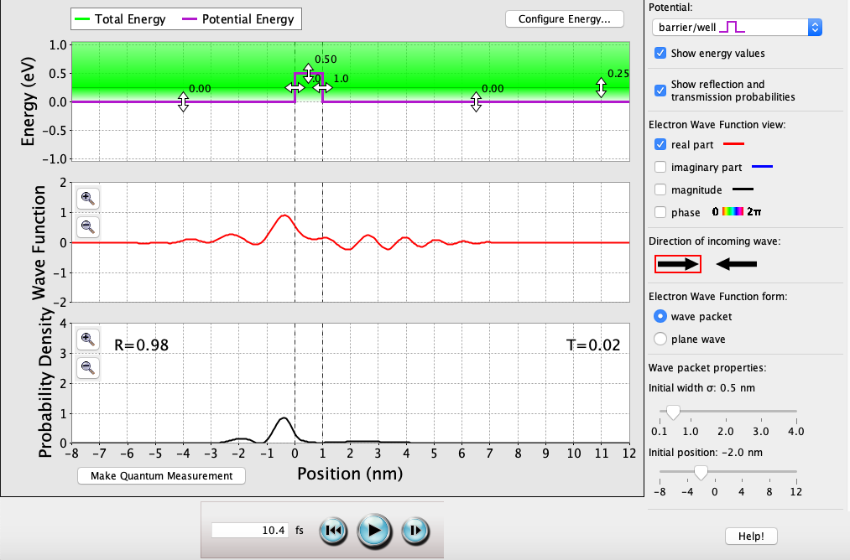

## Single-Well Potential (continued)

*Varying well-width:*

**VW = 0.1 nm**: T = 0.94.

Where *k0.5* = √(2*me*[*V2 - E*] / *ħ*2) ≈ 2.56 \* 109 (kg · J-1 · s-2)1/2.

And since E < V2, then T = (1 + [*V2*2sinh2(*k0.5a*)]/[4*E*(*V2* - *E*)])-1 = 0.937 ≈ 0.94 when *a* = 0.1 nm.

As the width decreases, T increases and quantum tunneling becomes more likely.

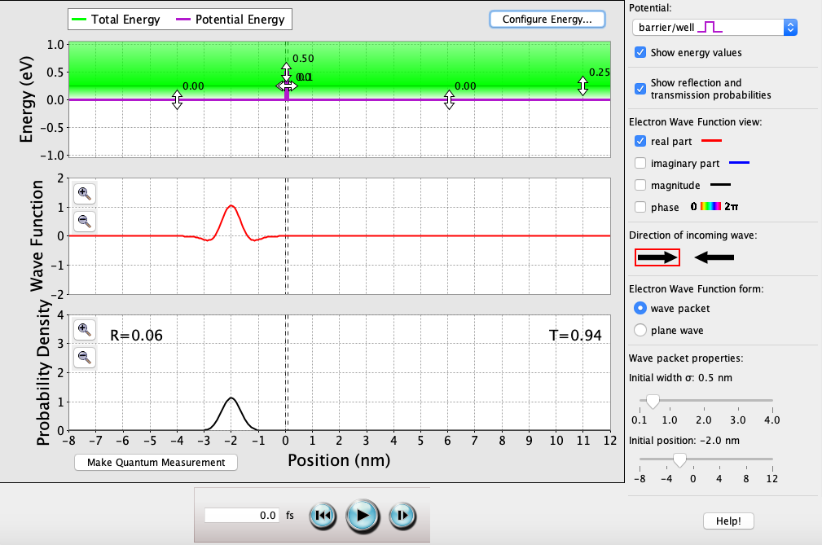

**VW = 0.5 nm**: T = 0.28.

Where *k0.5* = √(2*me*[*V2 - E*] / *ħ*2) ≈ 2.56 \* 109 (kg · J-1 · s-2)1/2.

And since E < V2, then T = (1 + [*V2*2sinh2(*k0.5a*)]/[4*E*(*V2* - *E*)])-1 = 0.266 ≈ 0.28 when *a* = 0.5 nm.

As the width increases, T decreases and quantum tunneling becomes less likely.

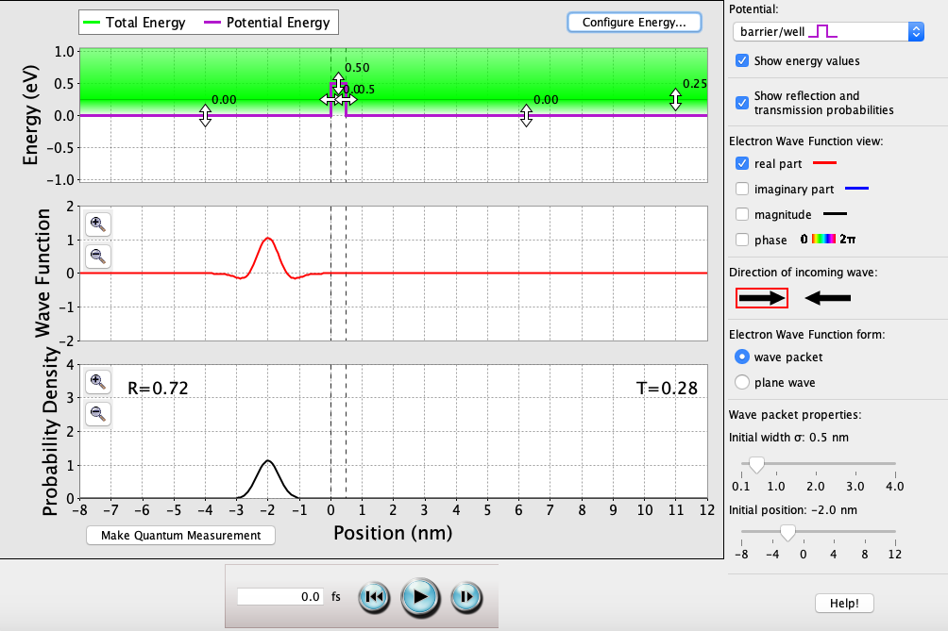

**VW = 2.0 nm**: T = 0.

Where *k0.5* = √(2*me*[*V2 - E*] / *ħ*2) ≈ 2.56 \* 109 (kg · J-1 · s-2)1/2.

And since E < V2, then T = (1 + [*V2*2sinh2(*k0.5a*)]/[4*E*(*V2* - *E*)])-1 ≈ 0 when *a* = 0.5 nm.

As the width increases dramatically, T becomes 0 and quantum tunneling becomes impossible.

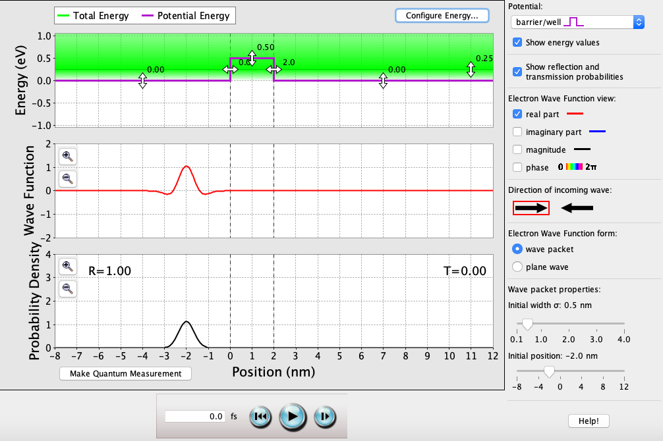

## Single-Well Potential (continued)

*Varying well-height:*

**V2 = 0 eV**: T = 1.00.

Where *k0* = √(2*me*[*E* – *V2*] / *ħ*2) = 0 (kg · J-1 · s-2)1/2.

As long as E > V2, the perfect transmission probability oscillates with each solution of *k0a* = *n*π 🡪 *n* = *k0a*/π, and in this case *a* = 0 nm. So (0 (kg · J-1 · s-2)1/2) \* 1.0 nm / π = 0 = (n = 0), so T = 1.00.

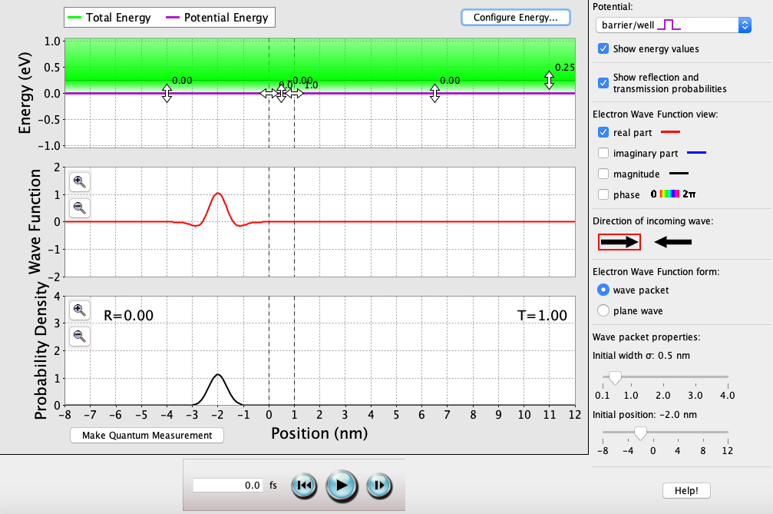

**V2 = 0.25 eV**: T = 0.38.

Where *k0.25* = √(2*me*[*E* – *V2*] / *ħ*2) = 0 (kg · J-1 · s-2)1/2.

And since E = V0, T = (1+*mea2V2* / 2*ħ*2)-1 = 0.379 ≈ 0.38.

When E = V2, the only way the electron can overcome the barrier is by quantum tunneling.

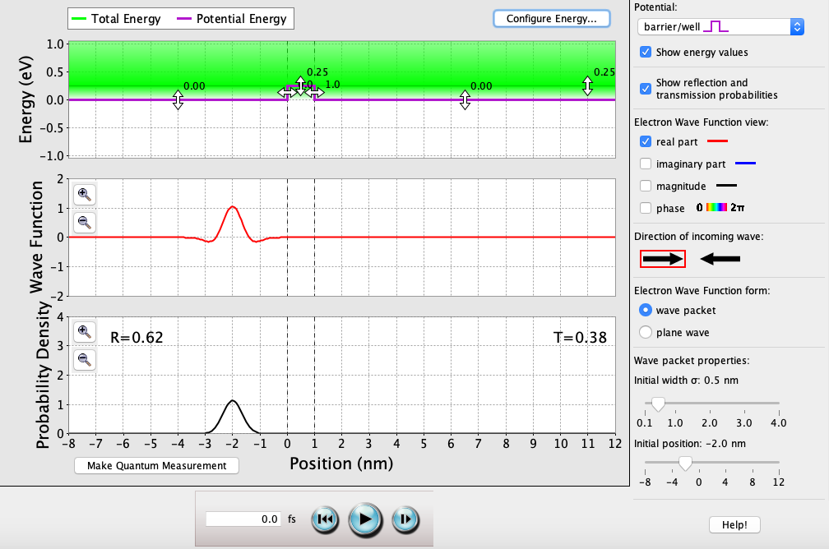

**V2 = 1.00 eV**: T = 0.

Where *k1.00* = √(2*me*[*V2 - E*] / *ħ*2) ≈ 4.44 \* 109 (kg · J-1 · s-2)1/2.

And since E < V2, then T = (1 + [*V2*2sinh2(*k1.00a*)]/[4*E*(*V2* - *E*)])-1 ≈ 0.

As the height increases dramatically, T becomes 0 and quantum tunneling becomes impossible.

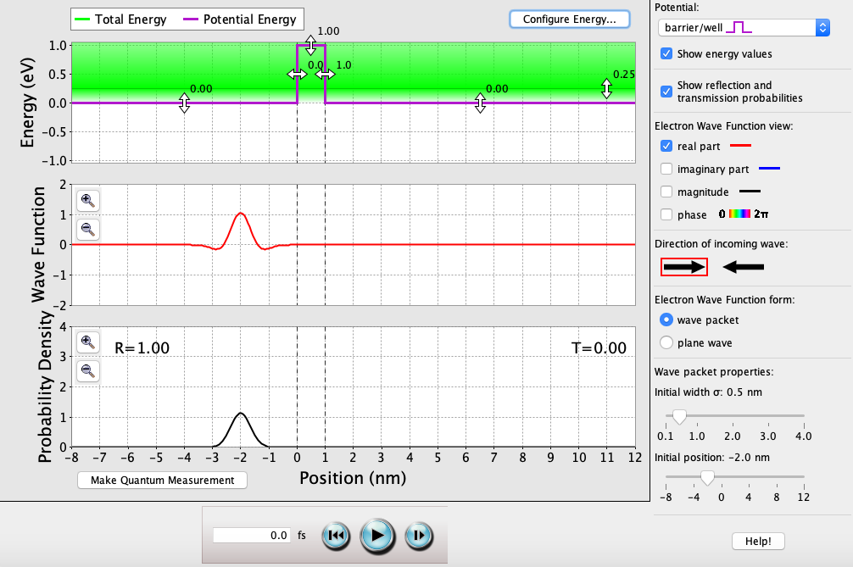

## Single-Well Potential (continued)

**E < V1, V2, V3**

**0 fs**: T = ?. As long as E is less than all of V1, V2, & V3, the electron will never exist within these bounds. This is because the barrier width approaches ∞ nm.

**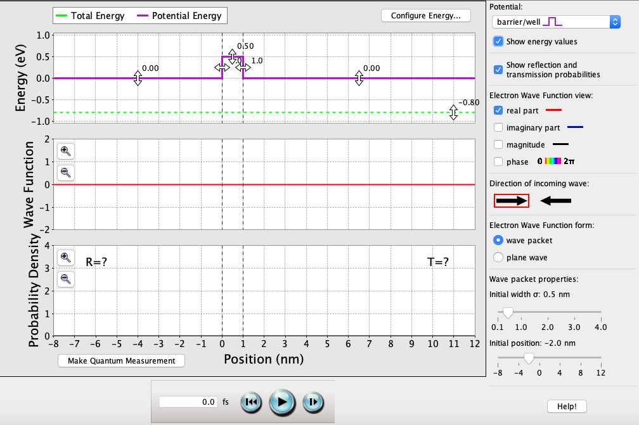**

**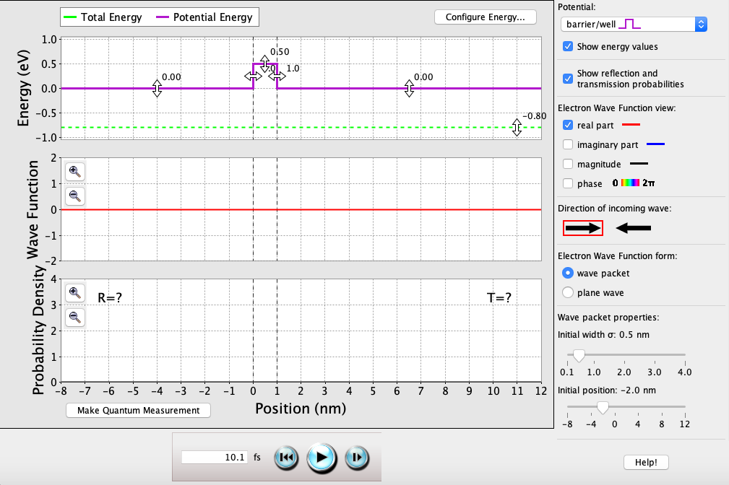**

**10 fs**: T = ?. Regardless of the time passed, E is always less than V1, V2, & V3, and the electron will never exist within these bounds. This is because the barrier width approaches ∞ nm.

## Double-Well Potential

**E > V1, V2, V3, V4, V5**

**0 fs**: T = 0.97. As long as E is greater than all of V1, V2, V3, V4, & V5, the electron will most likely transmit through the entire double-well potential.

**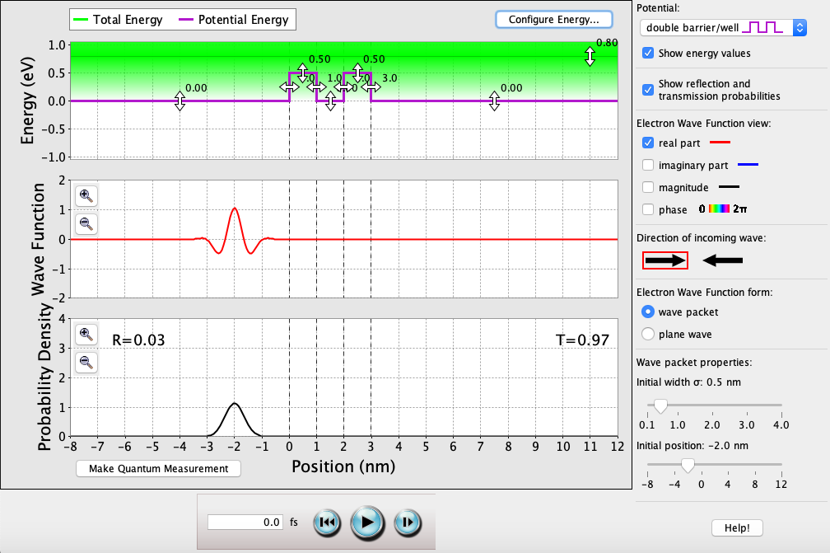**

**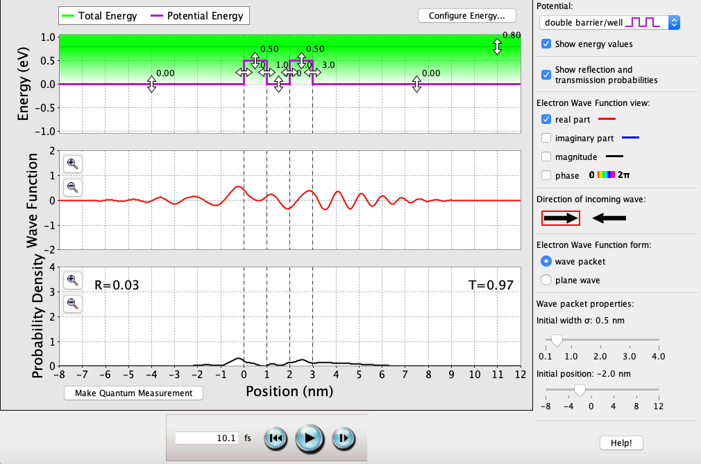**

**10 fs**: T = 0.97. Majority of the wave function will be transmitted through into V2, and even less of that will be transmitted through into V4. As long as E is greater than all of V1, V2, V3, V4, & V5, the electron will most likely transmit across the entire double-well.

## Double-Well Potential (continued)

*Varying well-widths:*

**V2W = V4W = 1.1 nm**: T = 1.00.

Where *k0.5* = √(2*me*[*E* – *V2,4*] / *ħ*2) ≈ 2.81 \* 109 (kg · J-1 · s-2)1/2.

As long as E > V2,4, the perfect transmission probability oscillates with each solution of *ka* = *n*π 🡪 *n* = *ka*/π, and in this case *aQW1* = *aQW2* = 1.1 nm.

So (2.81 \* 109 (kg · J-1 · s-2)1/2) \* 1.1 nm / π = 0.98 ≈ (n = 1), so T = T1 \* T2 = 1.00.

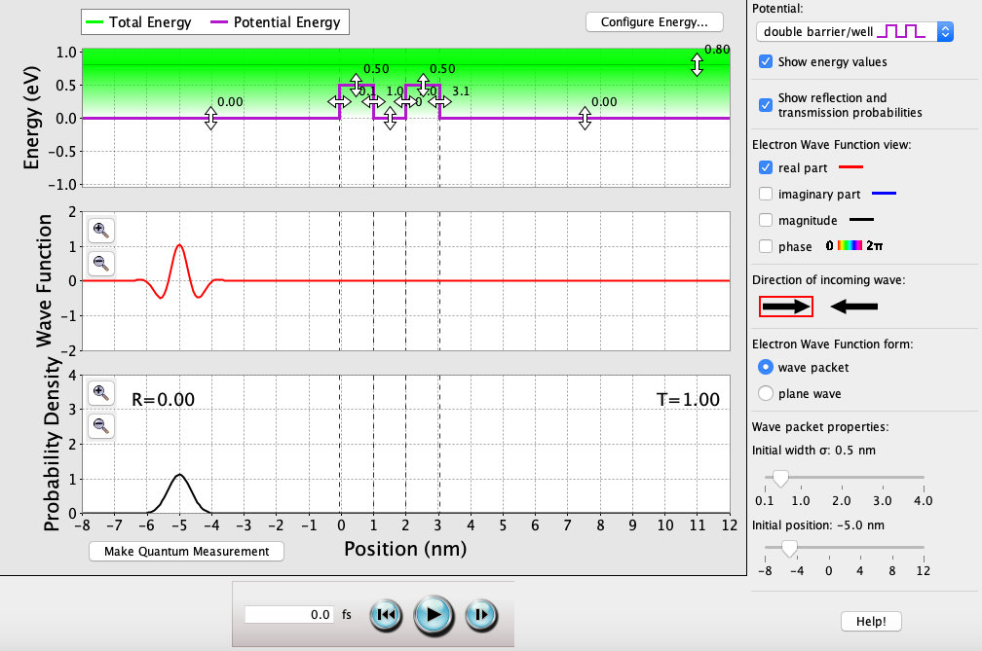

**V2W = V4W = 2.2 nm**: T = 1.00.

Where *k0.5 =* √(2*me*[*E* – *V2,4*] / *ħ*2) ≈ 2.81 \* 109 (kg · J-1 · s-2)1/2.

As long as E > V2,4, the perfect transmission probability oscillates with each solution of *ka* = *n*π 🡪 *n* = *ka*/π, and in this case *aQW1* = *aQW2* = 2.2 nm.

So (2.81 \* 109 (kg · J-1 · s-2)1/2) \* 2.2 nm / π = 1.96 ≈ (n = 2), so T = T1 \* T2 = 1.00.

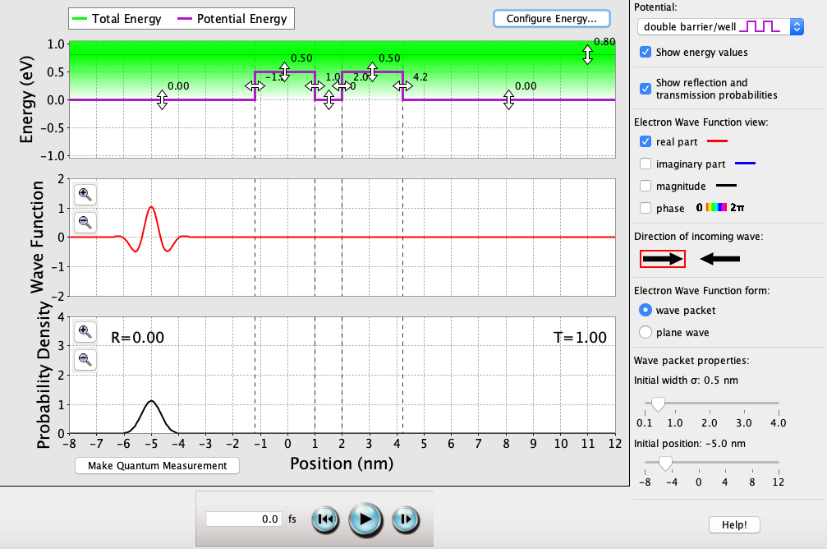

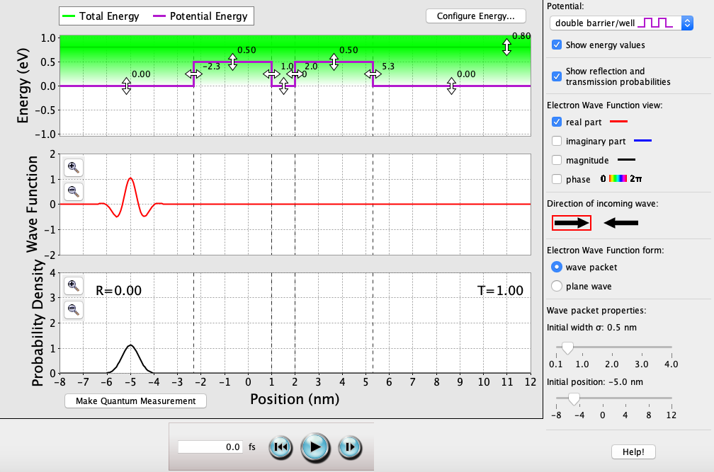

**V2W = V4W = 3.3 nm**: T = 1.00.

Where *k0.5 =* √(2*me*[*E* – *V2,4*] / *ħ*2) ≈ 2.81 \* 109 (kg · J-1 · s-2)1/2.

As long as E > V2,4, the perfect transmission probability oscillates with each solution of *ka* = *n*π 🡪 *n* = *ka*/π, and in this case *aQW1* = *aQW2* = 3.3 nm.

So (2.81 \* 109 (kg · J-1 · s-2)1/2) \* 3.3 nm / π = 3.03 ≈ (n = 3), so T = T1 \* T2 = 1.00.

## Double-Well Potential (continued)

*Varying well-heights:*

**V2 = V4 = -0.70 eV**: T = 1.00.

Where *k-0.70* = √(2*me*[*E* – *V2,4*] / *ħ*2) ≈ 6.27 \* 109 (kg · J-1 · s-2)1/2.

As long as E > V2,4, the perfect transmission probability oscillates with each solution of *k-0.70a* = *n*π 🡪 *n* = *k-0.70a*/π, and in this case *aQW1* = *aQW2* = 1.0 nm.

So (6.27 \* 109 (kg · J-1 · s-2)1/2) \* 1.0 nm / π = 1.99 ≈ (n = 2), so T = T1 \* T2 = 1.00.

**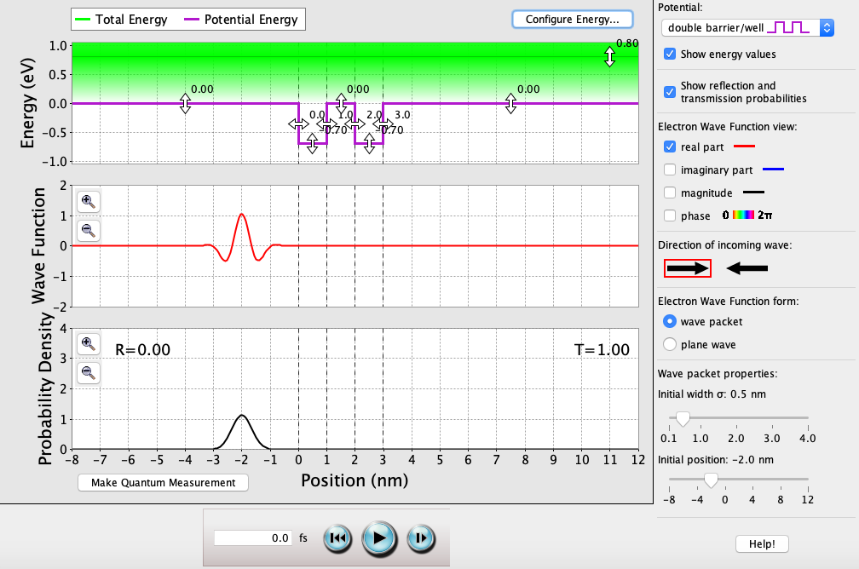**

**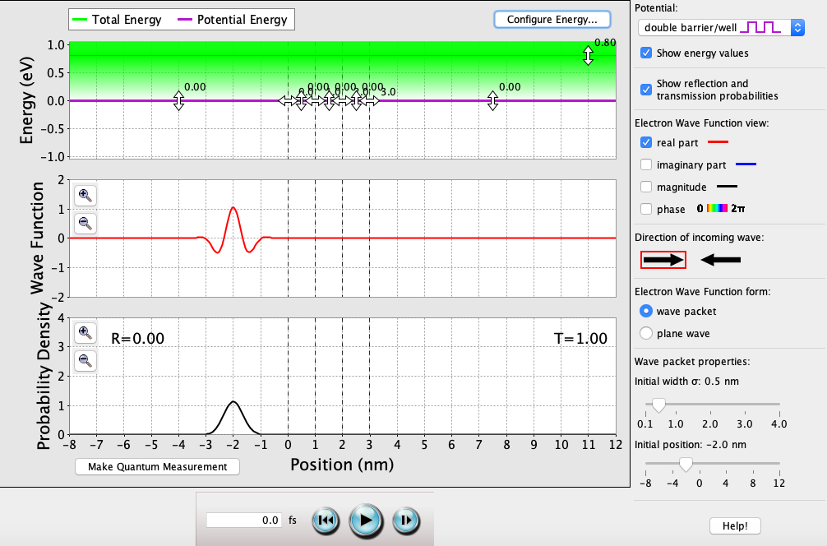**

**V2 = V4 = 0 eV**: T = 1.00.

Where *k0* = √(2*me*[*E* – *V2,4*] / *ħ*2) = 0 (kg · J-1 · s-2)1/2.

As long as E > V2,4, the perfect transmission probability oscillates with each solution of *k0a* = *n*π 🡪 *n* = *k0a*/π, and in this case *aQW1* = *aQW2* = 0 nm.

So (0 (kg · J-1 · s-2)1/2) \* 1.0 nm / π = 0 = (n = 0), so T = T1 \* T2 = 1.00.

**V2 = V4 = 0.42 eV**: T = 1.00.

Where *k0.42* = √(2*me*[*E* – *V2,4*] / *ħ*2) ≈ 3.16 \* 109 (kg · J-1 · s-2)1/2.

As long as E > V2,4, the perfect transmission probability oscillates with each solution of *k0.42a* = *n*π 🡪 *n* = *k0.42a*/π, and in this case *aQW1* = *aQW2* = 1.0 nm.

So (3.16 \* 109 (kg · J-1 · s-2)1/2) \* 1.0 nm / π = 1.01 ≈ (n = 1), so T = T1 \* T2 = 1.00.

**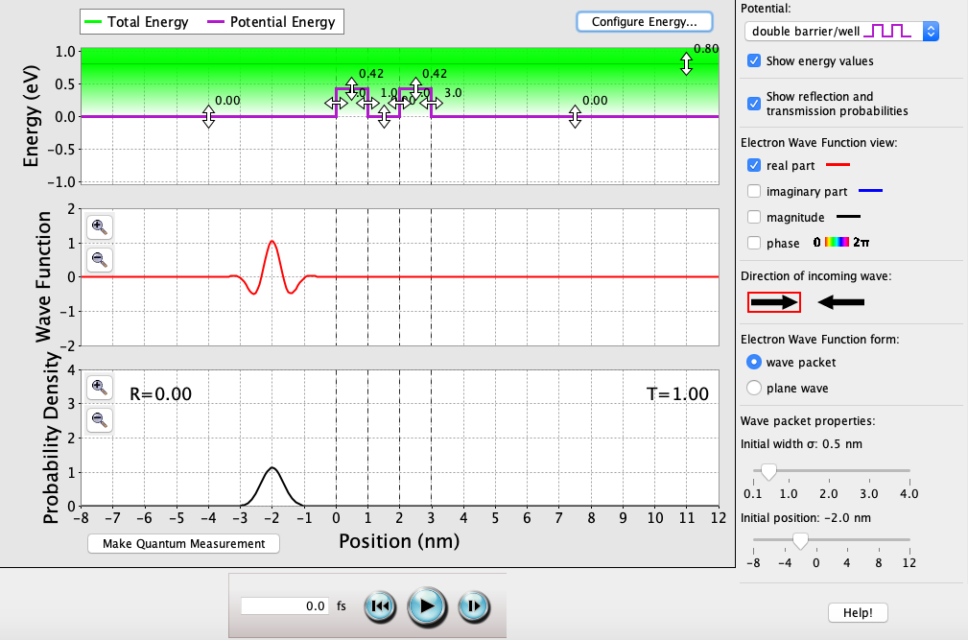**

## Double-Well Potential (continued)

**E > V1, V2, V3, V5**

**0 fs**: T = 0.02. As long as E is greater than all of V1, V2, V3, & V5, the situation essentially becomes similar to a single quantum well. The only way for the electron to overcome the barrier V4 is through quantum tunneling.

**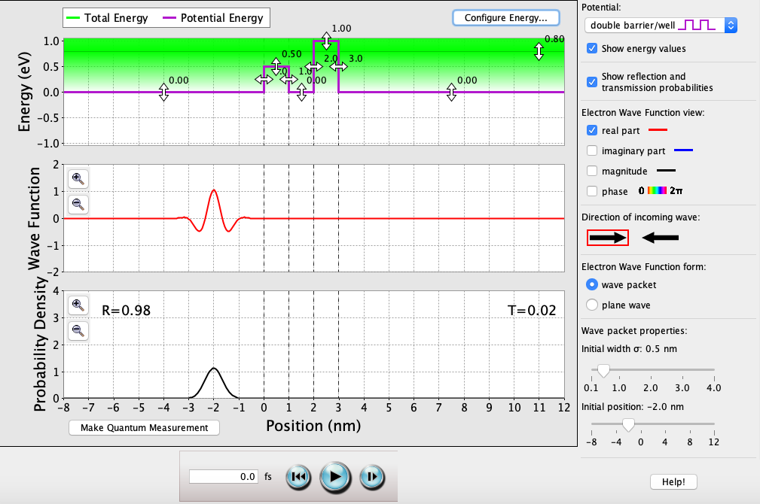**

**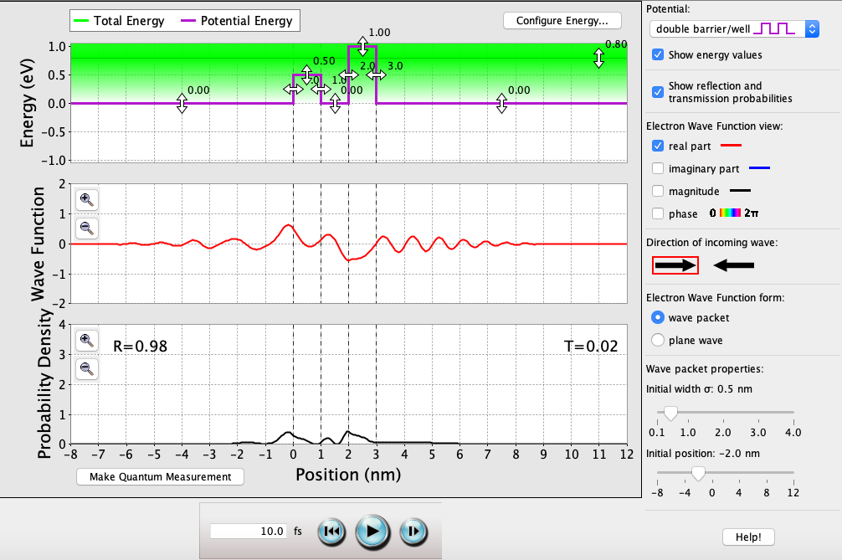**

**10 fs**: T = 0.02. Majority of the wave function will be reflected off V3, and majority of what’s left of that will be reflected off V4. The 0.02 probability that makes it through the well is the result of quantum tunneling.

## Double-Well Potential (continued)

*Varying well-widths:*

**V2W = 1.2 nm**: T = 0.03.

Where *k0.5* = √(2*me*[*E* – *V2*] / *ħ*2) ≈ 2.81 \* 109 (kg · J-1 · s-2)1/2 and *k1.00* = √(2*me*[*V4 - E*] / *ħ*2) ≈ 4.44 \* 109 (kg · J-1 · s-2)1/2.

As long as E > V2, the perfect transmission probability oscillates with each solution of *k0.5a* = *n*π 🡪 *n* = *k0.5a*/π, and in this case *a* = 1.2 nm. So (2.81 (kg · J-1 · s-2)1/2) \* 1.2 nm / π = 0.98 = (n = 1), so T1 = 1.00.

And since E < V4, then T2 = (1 + [*V4*2sinh2(*k1.00a*)]/[4*E*(*V4* - *E*)])-1 ≈ 0.000356.

So T = T1 \* T2 = 0.03.

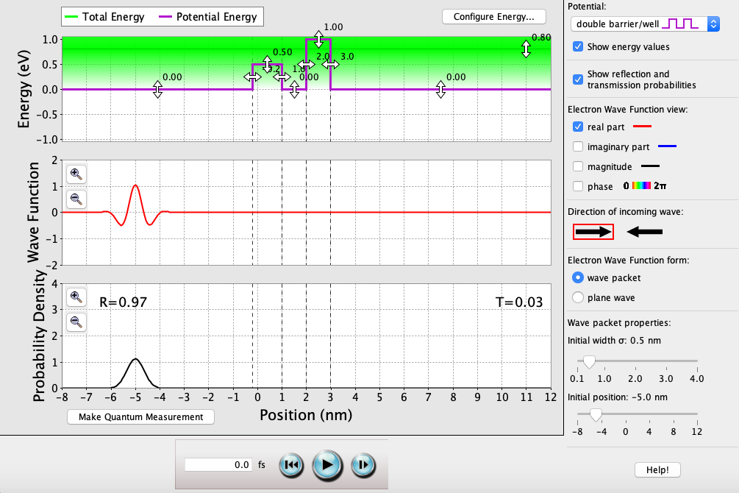

**V2W = 2.4 nm**: T = 0.03.

Where *k0.5* = √(2*me*[*E* – *V2*] / *ħ*2) ≈ 2.81 \* 109 (kg · J-1 · s-2)1/2 and *k1.00* = √(2*me*[*V4 - E*] / *ħ*2) ≈ 4.44 \* 109 (kg · J-1 · s-2)1/2.

As long as E > V2, the perfect transmission probability oscillates with each solution of *k0.5a* = *n*π 🡪 *n* = *k0.5a*/π, and in this case *a* = 2.4 nm. So (2.81 (kg · J-1 · s-2)1/2) \* 2.4 nm / π = 1.96 = (n = 2), so T1 = 1.00.

And since E < V4, then T2 = (1 + [*V4*2sinh2(*k1.00a*)]/[4*E*(*V4* - *E*)])-1 ≈ 0.000356.

So T = T1 \* T2 = 0.03.

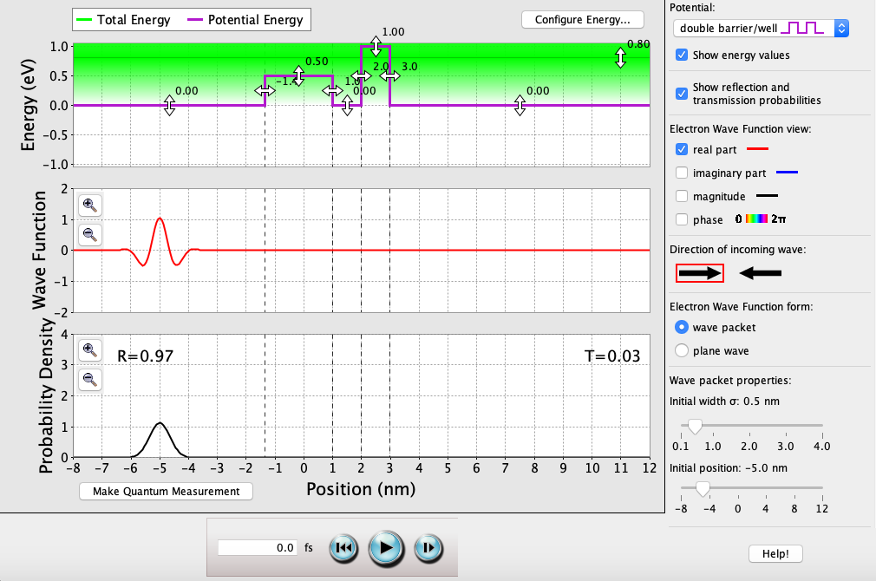

**V2W = 4.6 nm**: T = 0.03.

Where *k0.5* = √(2*me*[*E* – *V2*] / *ħ*2) ≈ 2.81 \* 109 (kg · J-1 · s-2)1/2 and *k1.00* = √(2*me*[*V4 - E*] / *ħ*2) ≈ 4.44 \* 109 (kg · J-1 · s-2)1/2.

As long as E > V2, the perfect transmission probability oscillates with each solution of *k0.5a* = *n*π 🡪 *n* = *k0.5a*/π, and in this case *a* = 4.6 nm. So (2.81 (kg · J-1 · s-2)1/2) \* 4.6 nm / π = 4.01 = (n = 4), so T1 = 1.00.

And since E < V4, then T2 = (1 + [*V4*2sinh2(*k1.00a*)]/[4*E*(*V4* - *E*)])-1 ≈ 0.000356.

So T = T1 \* T2 = 0.03.

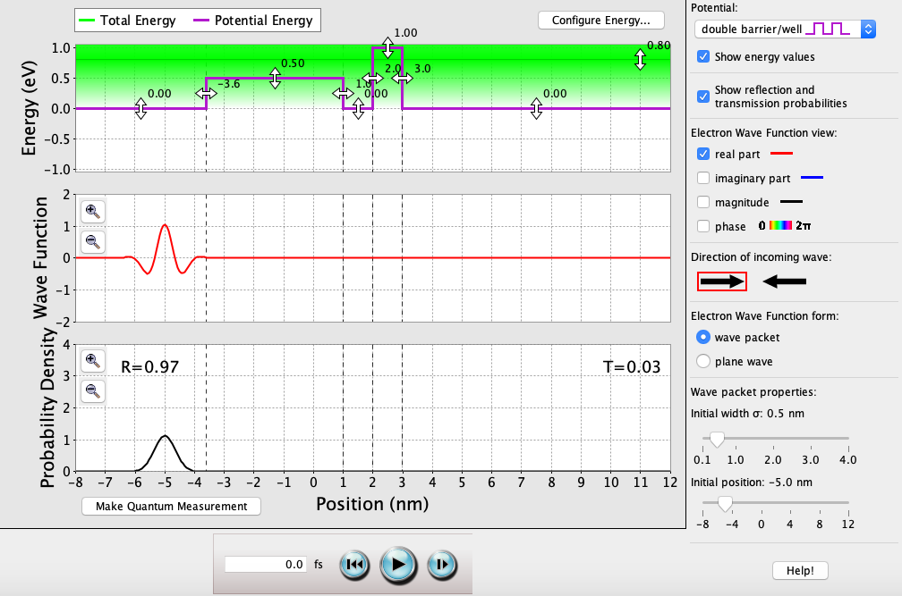

## Double-Well Potential (continued)

*Varying well-heights:*

**V2 = -0.5 eV**: T = 0.03.

Where *k0.5* = √(2*me*[*V2 - E*] / *ħ*2) ≈ 2.81 \* 109 (kg · J-1 · s-2)1/2 and *k1.00* = √(2*me*[*V4 - E*] / *ħ*2) ≈ 4.44 \* 109 (kg · J-1 · s-2)1/2.

As long as E > V2, the perfect transmission probability oscillates with each solution of *k0.5a* = *n*π 🡪 *n* = *k0.5a*/π, and in this case *a* = 1.2 nm. So (2.81 (kg · J-1 · s-2)1/2) \* 1.2 nm / π = 0.98 = (n = 1), so T1 = 1.00.

And since E < V4, then T2 = (1 + [*V4*2sinh2(*k1.00a*)]/[4*E*(*V4* - *E*)])-1 ≈ 0.000356.

So T = T1 \* T2 = 0.03.

**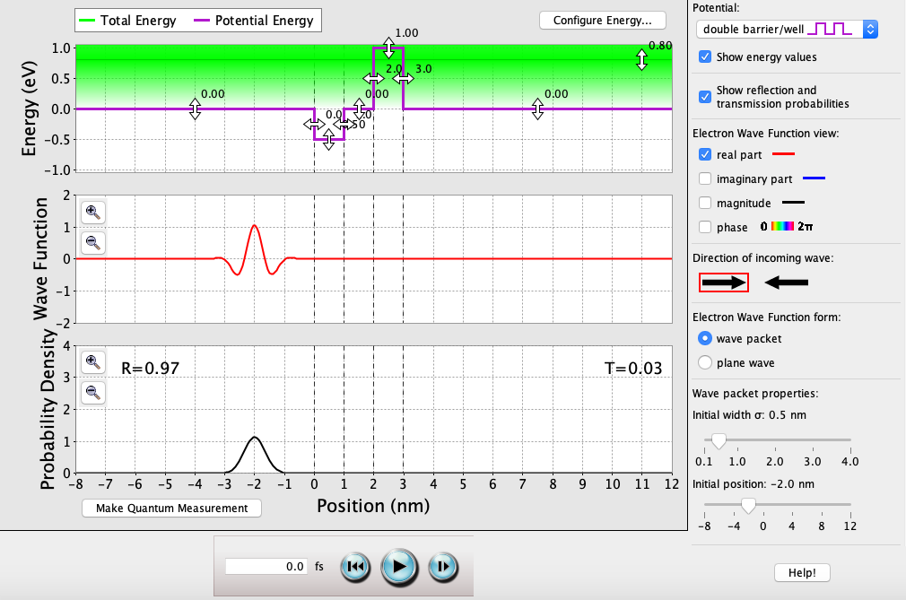**

**V2 = 0 eV**: T = 0.03.

Where *k0.5* = √(2*me*[*V2 - E*] / *ħ*2) ≈ 2.81 \* 109 (kg · J-1 · s-2)1/2 and *k1.00* = √(2*me*[*V4 - E*] / *ħ*2) ≈ 4.44 \* 109 (kg · J-1 · s-2)1/2.

As long as E > V2, the perfect transmission probability oscillates with each solution of *k0.5a* = *n*π 🡪 *n* = *k0.5a*/π, and in this case *a* = 1.2 nm. So (2.81 (kg · J-1 · s-2)1/2) \* 1.2 nm / π = 0.98 = (n = 1), so T1 = 1.00.

And since E < V4, then T2 = (1 + [*V4*2sinh2(*k1.00a*)]/[4*E*(*V4* - *E*)])-1 ≈ 0.000356.

So T = T1 \* T2 = 0.03.

**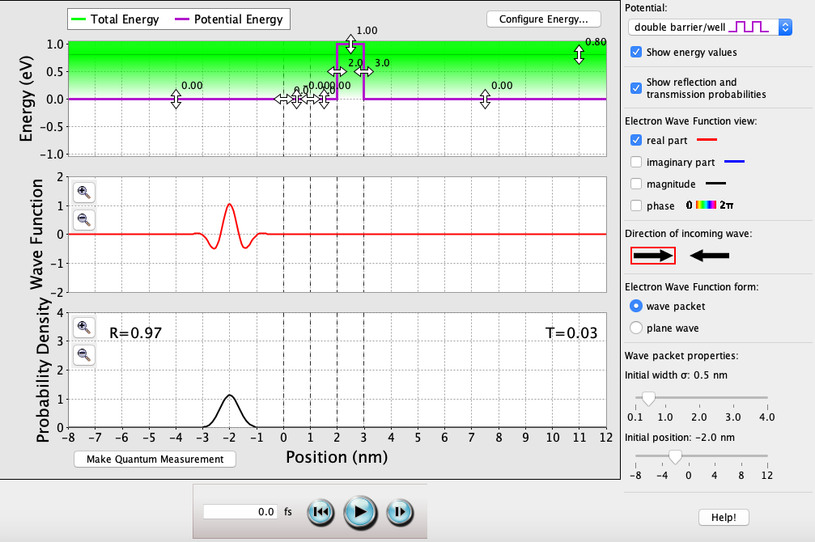**

**V2 = 0.8 eV**: T = 0.03.

Where *k0.5* = √(2*me*[*V2 - E*] / *ħ*2) ≈ 2.81 \* 109 (kg · J-1 · s-2)1/2 and *k1.00* = √(2*me*[*V4 - E*] / *ħ*2) ≈ 4.44 \* 109 (kg · J-1 · s-2)1/2.

As long as E > V2, the perfect transmission probability oscillates with each solution of *k0.5a* = *n*π 🡪 *n* = *k0.5a*/π, and in this case *a* = 1.2 nm. So (2.81 (kg · J-1 · s-2)1/2) \* 1.2 nm / π = 0.98 = (n = 1), so T1 = 1.00.

And since E < V4, then T2 = (1 + [*V4*2sinh2(*k1.00a*)]/[4*E*(*V4* - *E*)])-1 ≈ 0.000356.

So T = T1 \* T2 = 0.03.

**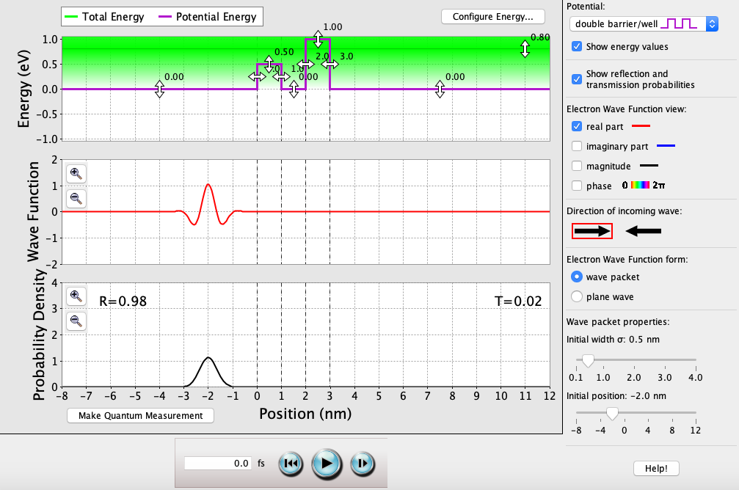**

## Double-Well Potential (continued)

**E > V1, V2, V3**

**0 fs**: T = 0. As long as E is less than both V2 & V4, the electron will never transmit through both wells. The only way for the electron to overcome the barriers V2 & V4 is through two quantum tunnels, which is near impossible due to the width & height of the wells.

**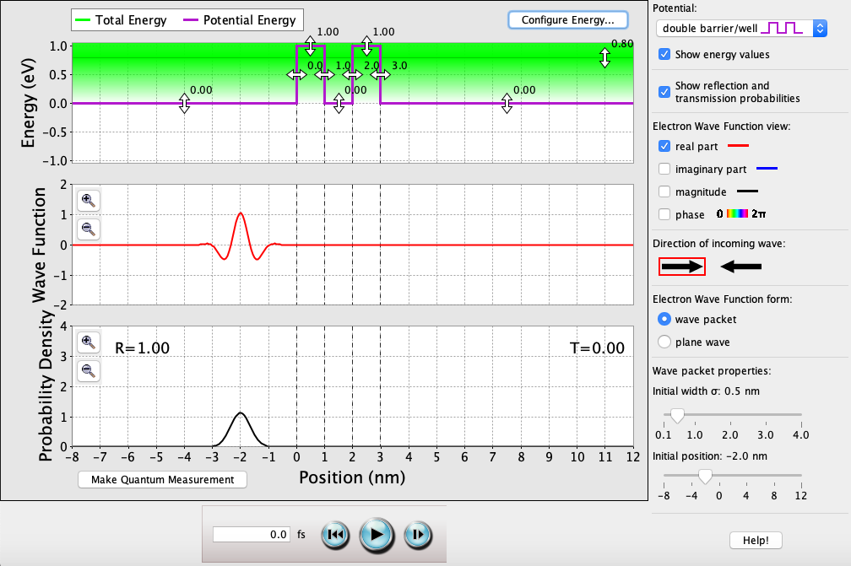**

**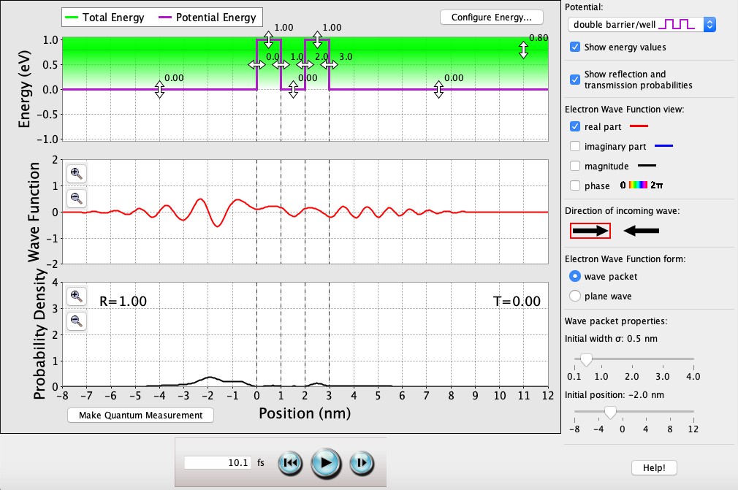**

**10 fs**: T = 0. Regardless of the time passed, E is always less than V2 & V4, and the electron will never tunnel through both bounds. This is because the potential barriers are too wide & tall.

## Double-Well Potential (continued)

*Varying well-widths:*

**V2W = 0.1 nm**: T = 0.27.

Calculations for T are extremely complex for double-well tunneling. As well width(s) decrease, T will increase and quantum tunneling becomes more likely.

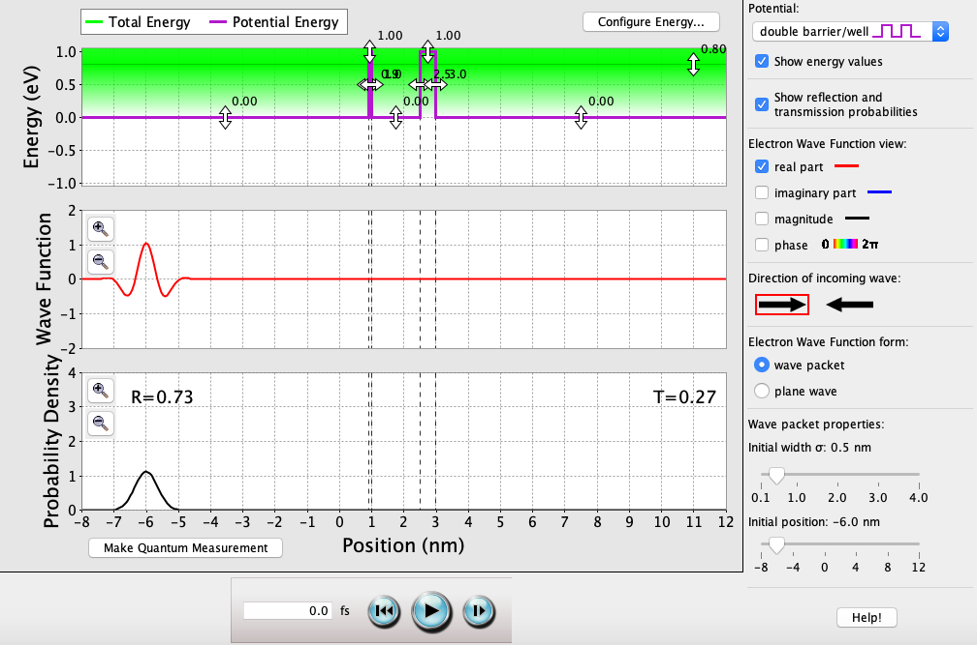

**V2W = 0.5 nm**: T = 0.12.

Calculations for T are extremely complex for double-well tunneling. As well width(s) increase, T will decrease and quantum tunneling becomes less likely.

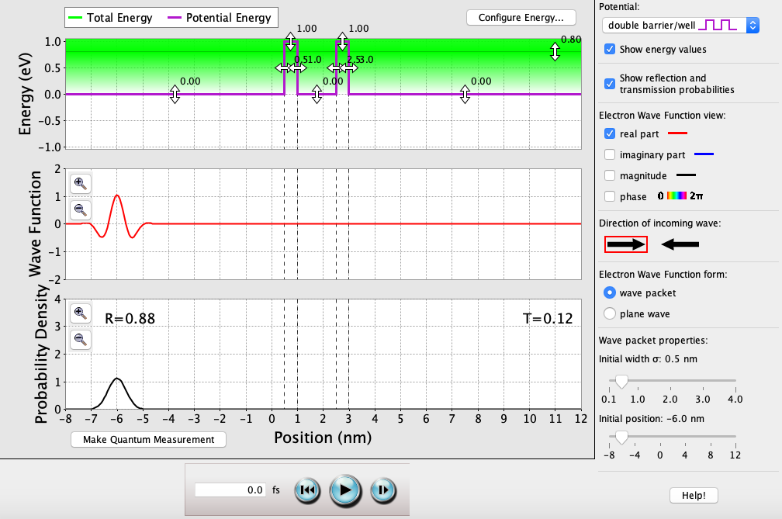

**V2W = 2.0 nm**: T = 0.

Calculations for T are extremely complex for double-well tunneling. As well width(s) greatly increase, T will become 0 and quantum tunneling becomes impossible.

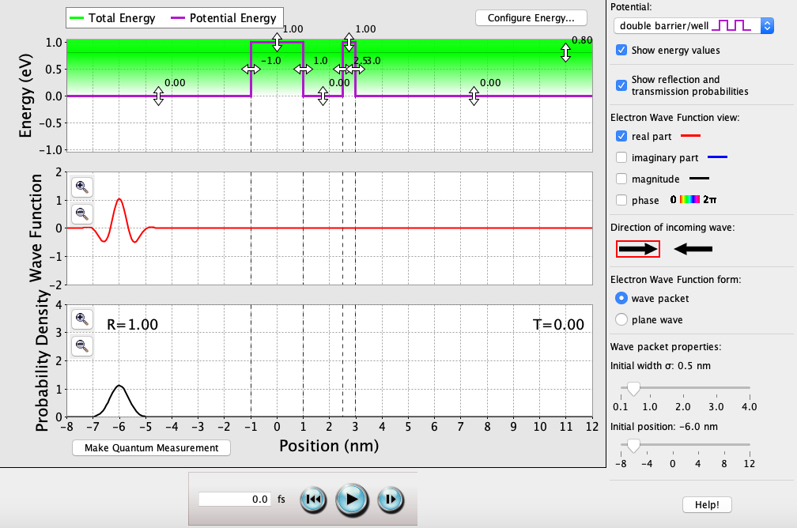

## Double-Well Potential (continued)

*Varying well-heights:*

**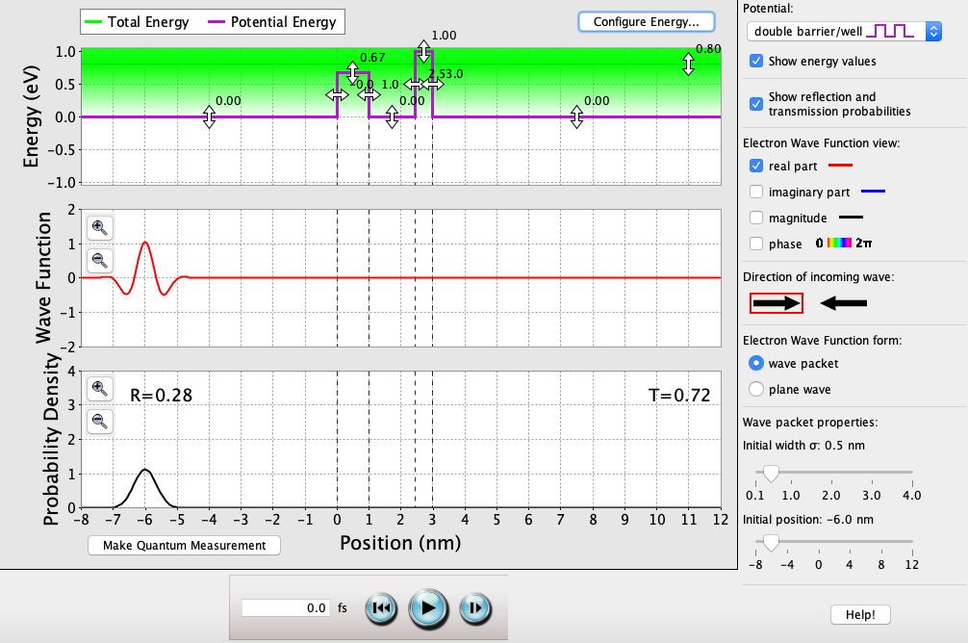**

**V2 = 0.67 eV**: T = 0.72.

Calculations for T are extremely complex for double-well potentials with single-well tunneling. As well height for V2 approaches satisfying *n* = *k0.67a*/π, T will increase and quantum tunneling becomes more likely.

**V2 = 0.16 eV**: T = 0.22.

Calculations for T are extremely complex for double-well potentials with single-well tunneling. As well height for V2 approaches not satisfying *n* = *k0.16a*/π, T will decrease and quantum tunneling becomes less likely.

**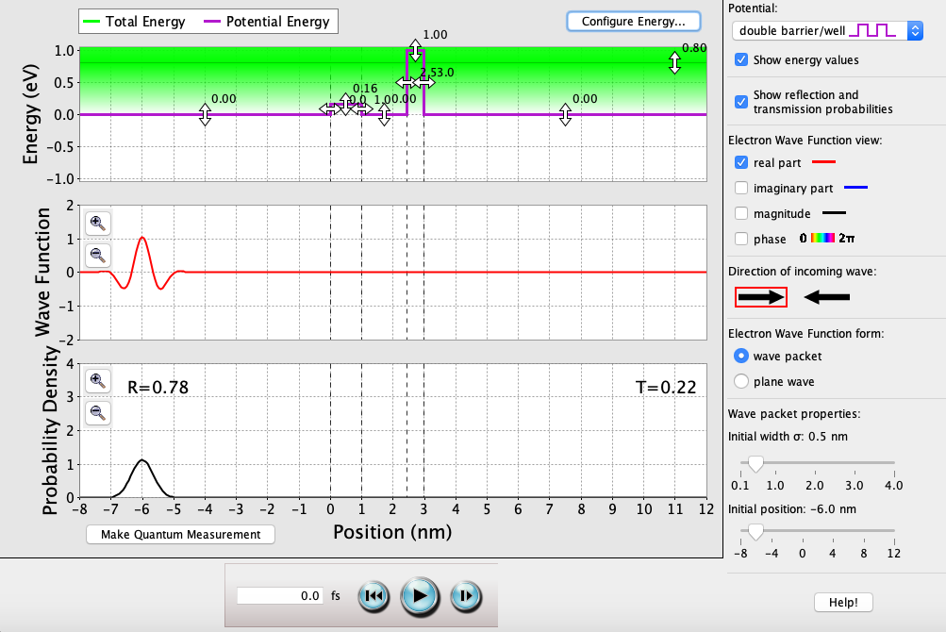**

**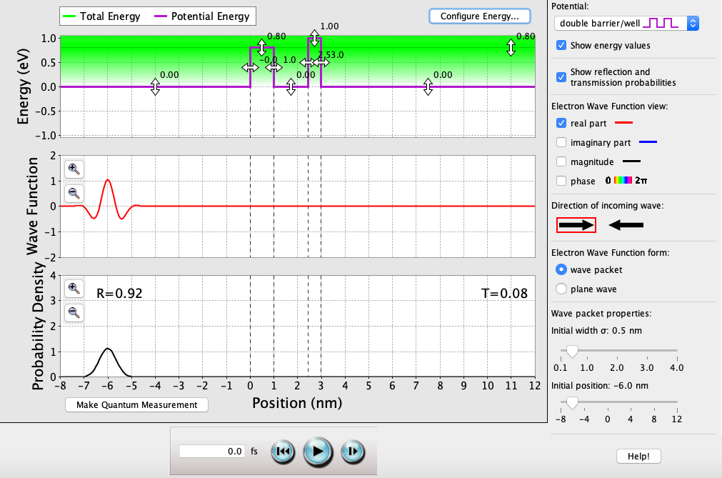**

**V2 = 0.8 eV**: T = 0.08.

Calculations for T are extremely complex for double-well tunneling. As well height(s) increase, T will decrease and quantum tunneling becomes less likely.

## Double-Well Potential (continued)

**E < V1, V2, V3, V4, V5**

**0 fs**: T = ?. As long as E is less than all of V1, V2, V3, V4, & V5, the electron will never exist within these bounds. This is because the barrier widths approach ∞ nm.

**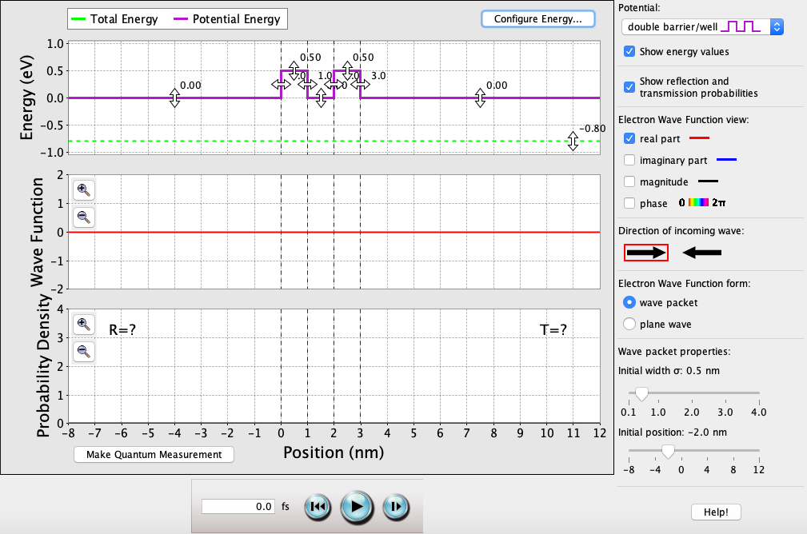**

**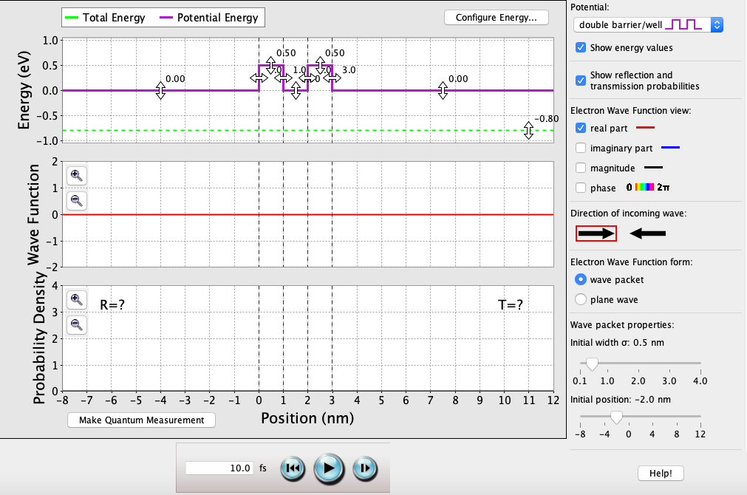**

**10 fs**: T = ?. Regardless of the time passed, E is always less than V1, V2, V3, V4, & V5, and the electron will never exist within these bounds. This is because the barrier widths approach ∞ nm.

# Applications

One of the first real-world applications of quantum tunneling resulted in one of the earliest atomic clocks; the frequency of the N atom in NH3 (ammonia) was measured and used due to the reliability of its tunneling rate. Quantum tunneling also plays a large part in understanding biology, specifically quantum biology, where there are instances of both electron tunneling and proton tunneling. The former takes place in many biochemical reactions, such as photosynthesis and cellular respiration, while the latter takes place in spontaneous mutation of DNA.

In electronics, perfecting components such as tunneling diodes and tunnel field-effect transistors will be vital to reducing the power consumption of almost every piece of technology in a world whose cost of power consumption continues to rise. Mastering quantum mechanics, and specifically tunneling, will be crucial in furthering quantum computing, which will allow for much more powerful technologies with much better power efficiency. While this specific field is being actively pursued in both academic and institutional research, mastering the use of quantum logic gates and quantum bits (qubits) begins with understanding and visualizing one its major cornerstones: quantum tunneling.

Fig. 5. Quantum computing will help revolutionize mankind’s approach to problems (Rosen).

# References

“A DOS for Quantum Computers Means We Are Getting Close to Seeing Them

Everywhere.” *21st Century Tech Blog*, 6 May 2015, www.21stcentech.com/quantum

computers-dos/.

Geppert, Linda. “Quantum Transistors: Toward Nanoelectronics.” *IEEE Spectrum:*

*Technology, Engineering, and Science News*, IEEE Spectrum, 1 Sept. 2000,

spectrum.ieee.org/computing/hardware/quantum-transistors-toward

nanoelectronics.

*Lecture 22*, www.physics.purdue.edu/cdf/241lecturesFall99/lc22/lc22\_1.html.

Luntz, Stephen. “Quantum Tunneling Is So Quick It Could Be Instantaneous.” *IFLScience*,

IFLScience, 9 Apr. 2019, www.iflscience.com/physics/quantum-tunneling-is-so

quick-it-could-be-instantaneous/.

*Quantum Tunneling*, abyss.uoregon.edu/~js/glossary/quantum\_tunneling.html.

“Quantum Tunnelling.” *Wikipedia*, Wikimedia Foundation, 8 Apr. 2019,

en.wikipedia.org/wiki/Quantum\_tunnelling#Introduction\_to\_the\_concept.

“Rectangular Potential Barrier.” *Wikipedia*, Wikimedia Foundation, 18 Dec. 2018,

en.wikipedia.org/wiki/Rectangular\_potential\_barrier.

Sainadh, U. Satya. “We Did a Breakthrough 'Speed Test' in Quantum Tunnelling, and Here's

Why That's Exciting.” *Phys.org*, Phys.org, 19 Mar. 2019, phys.org/news/2019-03

breakthrough-quantum-tunnelling.html.  
“The Science Behind Nanolog Devices.” *Nanolog Audio*, www.nanologaudio.com/nanolog

device-science.html.

“The Science behind Quantum Computers: Tunnelling and Entanglement.” *LinkedIn*,

www.linkedin.com/pulse/physics-behind-quantum-computers-entanglement

sahar-shoja.

*Wave-Particle Duality*, physics.bu.edu/py106/notes/Duality.html.